London Hydro Inc.
EB-2024-0040
January 22, 2025
Please note, London Hydro Inc. (London Hydro) is responsible for ensuring that all documents it files with the OEB, including responses to OEB staff questions and any other supporting documentation, do not include personal information as that phrase is defined in the Freedom of Information and Protection of Privacy Act, unless filed in accordance with rule 9A of the OEB’s Rules of Practice and Procedure.
Follow up Question-1
Account 1595 (2021)
Ref 1: Response to Staff Question-2
Ref 2: 2025 IRM rate model_20250114, DVA continuity, Tab 3
Ref 3: 2025 GA Workform, Tab PA, Cell V62 & Cell J62
Ref 4: 2025 IRM Application, pp15,16

Preamble:
Per Ref 1, London Hydro states the 2025 rate model has been updated with no reversal since the 2022 interest adjustments should not be reversed.

Per Ref 2, the updated continuity shows that Account 1588 RSVA Power balance has a $764,961 variance when compared to the RRR 2.1.7, which does not reconcile with Cell V62 (Account 1588 current year PA) in Ref 3 and the explanation in Ref 4. It also shows
Account 1589 RSVA GA balance has a ($646,309) variance when compared to the RRR 2.1.7, which does not reconcile with Cell J62 (Account 1589 current year PA) in Ref 3 and the explanation in Ref 4.

Question(s):
- Please explain/reconcile the noted difference above and updated the model/evidence.

Follow up Question-2
Account 1595 (2022) - interest
Ref 1: 2025 IRM rate model_20250114, DVA continuity, Tab 3

Preamble:
Per Ref 1, OEB staff notes the 2023 interest amount (Cell BI35) of Account 1595 Sub Account 2022 is a debit of $81,380 while the opening balance of the principal and the interest is a debit of $260,180 and a debit of $27,228, respectively.

Question(s):
- Please explain the high interest amount of $80k in 2023.

Follow up Question-3
Account 1588 - interest
Ref 1: 2025 IRM rate model_20250114, DVA continuity, Tab 3

Preamble:
Per Ref 1, OEB staff notes the 2023 interest amount (Cell BI28) of Account 1595 Sub Account 1588 RSVA Power is a debit $46,641 while the opening balance of the principal and the interest is a credit of ($507,102) and a debit of $21,787, respectively.

Question(s):
- Please explain why the credit opening principal balance ($507,102) will generate over a debit of $45k interest in 2023.

Follow up Question - 4
Ref 1: 2025 IRM rate model_20250114, DVA continuity, Tab 3
Ref 2: Staff Question-4, Updated Table 4
Ref 3: 2024 IRM rate model, DVA continuity, Tab 3

Question(s):
- The following highlighted amount in Ref 2 does not match with the Ref 1, please explain the variances and update the evidence as necessary.

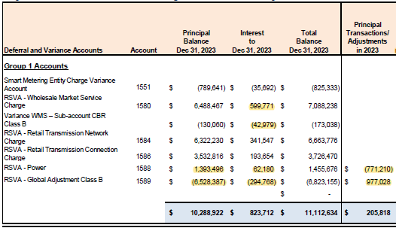

- Per Ref 2 & Ref 3 above, OEB staff has complied the following table. Based on the column name, the 2022 interest adjustments will be recorded in 2024. Please explain why the same interest adjustments in Ref 3 will be recorded again in 2024 per Ref 2.
 | Interest adjustment during 2022 (Ref 3) | 2022 Interest Adjustments recorded in 2024 (Ref 2)
1580 RSVA WMS | ($5,948) | ($5,948)
1580 CBR Class B | ($1,780) | ($1,780)
1588 RSVA-Power | $6,249 | $6,249
1589 RSVA-GA | ($323,867) | ($323,867)
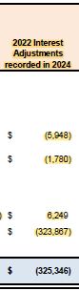

Follow up Question - 5
Ref 1: 2025 IRM rate model_20250114, Tab 11 RTSR – UTRs & Sub-Tx, EB-2024-0244 2025 UNIFORM TRANSMISSION RATES January 21, 2025 and EB-2024-0032 Hydro One Networks Inc. Rate Order, December 19, 2024
Preamble:
Distributors must enter the applicable rates in the Rate Generator Model for the preliminary Uniform Transmission Rates (UTRs) and Hydro One Sub-Transmission Rates. These rates must align with the most recent rates and charges issued by the OEB.
Question(s):
- OEB staff has updated Tab 11 RTSR – UTRs & Sub Tx UTRs. Please confirm the updates and ensure that all tabs are updated accordingly.

