Hearst Power Distribution Co. Ltd.
EB-2024-0029
[January 28, 2025]
Please note, Hearst Power Distribution Co. Ltd. (Hearst Power) is responsible for ensuring that all documents it files with the OEB, including responses to OEB staff questions and any other supporting documentation, do not include personal information as that phrase is defined in the Freedom of Information and Protection of Privacy Act, unless filed in accordance with rule 9A of the OEB’s Rules of Practice and Procedure.
Follow-up Question #1
Ref. 1: Staff Question – 2

Preamble:
In response to OEB staff questions, Hearst Power updated Tab 3 of the Rate Generator Model with the Q4 2024 interest rate of 4.4%.

On December 11, 2024, the OEB published the Q1 2025 prescribed accounting interest rate applicable to the carrying charges of deferral, variance and construction work in progress (CWIP) accounts of natural gas utilities, electricity distributors and other rate-regulated entities.

Question(s):
- Please update Tab 3 (Continuity Schedule) as necessary to reflect the Q1 2025 OEB-prescribed interest rate of 3.64% for the Rate Generator Model.

Hearst Power:
- The model filed along with these responses has been updated accordingly.

Follow-up Question #2
Ref. 1: Staff Question – 5
Ref. 2: HPDCL_2021 Rev_Reqt_Workform SettlConf 20210525, Tabs 4 and 6

Preamble:
Hearst Power has provided evidence that the values in the 2025 IRM filing is consistent with the 2022, 2023, and 2024 IRM filings. OEB staff notes that there is still a discrepancy between the 2021 Cost of Service (CoS) application and the subsequent filings. OEB staff has updated the Rate Generator Model with the values taken from the 2021 CoS. A screenshot from the Hearst Power’s 2021 CoS Revenue Requirement Workform is attached for reference.
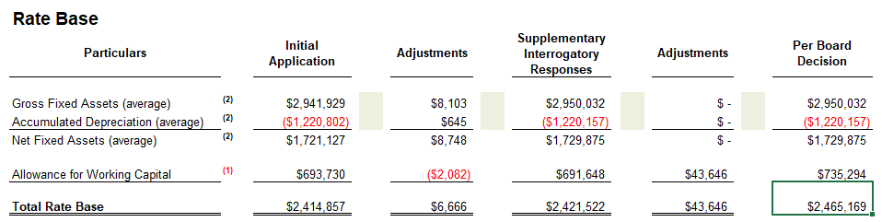
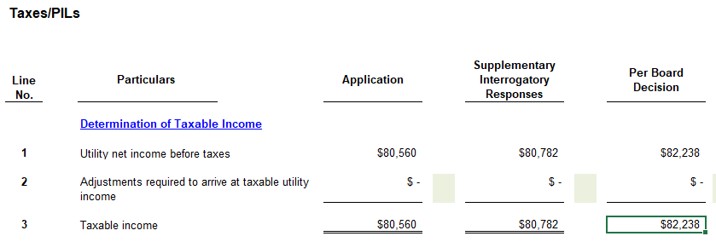

Question(s):
- Please confirm the values updated by the OEB staff. If not, please provide reasoning for why the values should differ from the 2021 CoS.

Hearst Power: As is customary, LDCs are supposed to use the adjusted from Tab Sch 1 Taxable Income Test which clearly shows an adjusted regulatory income of -46,130 as shown in the screenshot below.
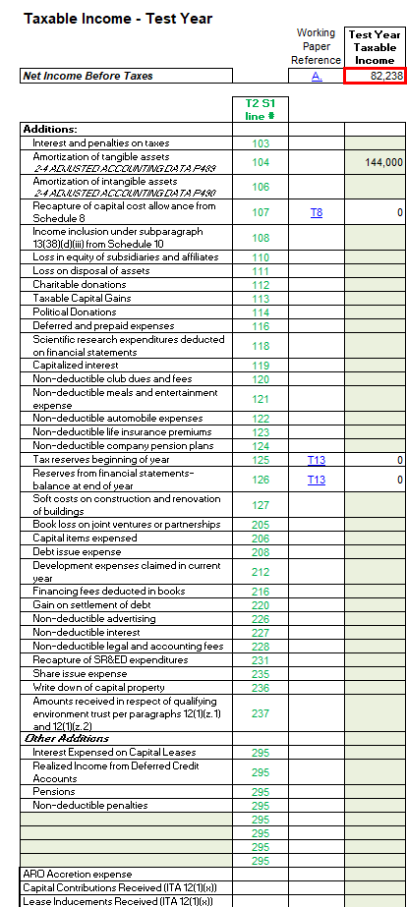
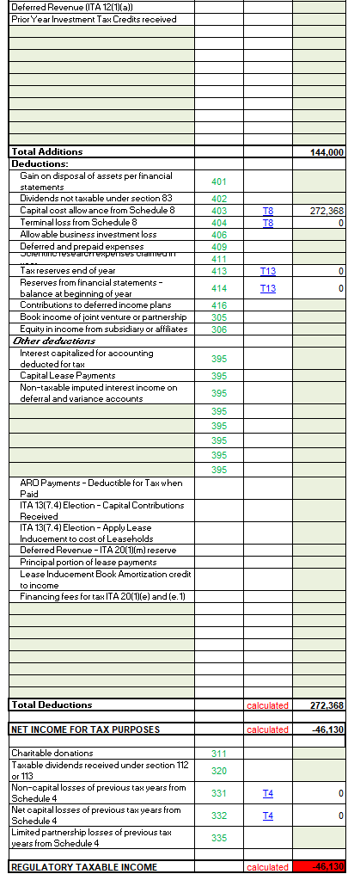
Follow-up Question #3
Ref. 1: Staff Question – 11a

Preamble:
The transaction amount reported in the GA Workform has a reversed sign compared to the Rate Generator Model. According to the supporting document (Tab Monthly RSVA) provided by Hearst Power, the total transaction should be a credit amount of $124,839.69 which ties with the amount reported in the Rate Generator Model. Therefore, the Account 1588 2023 transaction amount reported in the GA Workform should be updated to match the Rate Generator Model.

Question(s):
- Please make the necessary updates.

Hearst Power:
- Document has been updated with the negative sign

Follow-up Question #4
Ref. 1: Staff Question – 11b
Ref. 2: HPDCL_2025_GA_Analysis_workform_20250113, Tab Account 1588

Preamble:
In Staff Question 11, OEB staff asked Hearst Power to complete and file a Line Loss Analysis worksheet to provide more information on the impact of the overstated line loss on Account 1588. Hearst Power provided two worksheets and an accompanying explanation in Ref. 2 for why the balance of Account 1588 RSVA Power is relatively large compared to Account 4705 – Power Purchased. Hearst Power stated that:

Hearst Power has investigated the variance and has determined that it is attributed to the line losses, more specifically the Supply Facility Loss Factor (“SFLF”), approved in the 2021 Cost of Service vs the actual line losses that the utility is being charged.

At the time of the 2021 Cost of Service, Hearst Power used the OEB’s criteria to calculate its Supply Facility Loss Factor which included a weighting average of IESO controlled, Hydro One controlled and embedded generation. Hearst Power used a 1.0340 for the Hydro One portion as instructed in the directions from the OEB however, the actual Hydro One SFLF billed to Hearst Power contains two rates. More specifically, the Hydro One SFLF invoiced to Hearst Power includes a supply loss charge ratio of about 12% at 1.034 and 88% at 1.0060.

In EB-2020-007, the Board Approved line loss that was set at 5.98% but when considering the actual SFLF paid to Hydro One, it should have represented 4.60%. Hearst Power was not aware of the divergence prior to these interrogatories, the discussion with Hydro One and a review of the Hydro One provided Totalization tables. The variance calculated and identified in the GA workform can be attributed to the difference in the actual vs Board Approved SFLF loss factor. For 2023, -2.36% of the -2.7% variance is explained by a higher charged SFLF of 5.98% instead of 3.62% which represents $107,894 in account 1588 and is equal to 86% of the $124,839 variance.

Question(s):
- Please describe how Hearst Power plans to mitigate these discrepancies in its next rebasing application.

Hearst Power: This issue can be easily corrected in the next COS. Hearst Power will not use the OEB default values for the Supply Facility Loss Factor (e.g., IESO = 1.0045, Hydro One = 1.034). Instead, the SFLF will be calculated based on the weighted average of actual purchased power.

Follow-up Question #5
Ref. 1: Staff Question – 7

Preamble:
On January 21, 2025, the OEB issued a Decision and Rate Order regarding 2025 UTRs.
Updated UTRs

Network Service Rate | 6.37
Line Connection Service Rate | 1.00
Transformation Connection Service Rate | 3.39

OEB staff has updated Hearst Power’s Rate Generator Model with the 2025 UTRs.
Question(s):
- Please confirm the accuracy of the Rate Generator Model updates.

Hearst Power: The utility confirms that the UTRs stated above are accurate.

