
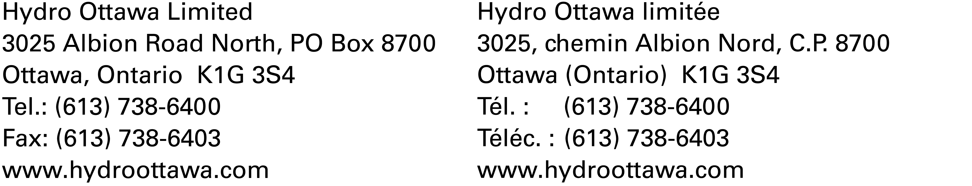
November 7, 2008

Ontario Energy Board
P.O. Box 2319
27th Floor
2300 Yonge Street
Toronto, ON M4P 1E4

Attention: Kirsten Walli
Board Secretary

Re: 2009 Electricity Distribution Rates
EB-2008-0188

Please find enclosed two hard copies and a CD of Hydro Ottawa Limited’s 2009 Electricity Distribution Rates Application.

A complete copy of the Application in searchable/unrestricted PDF format, one (1) electronic copy in Microsoft Excel format of the completed 3rd Generation IRM models and one (1) electronic copy of the Manager’s Summary have been filed electronically today through the Board’s web portal.

If further information is required, please contact the undersigned at 613-738-5499 ext 7499 or janescott@hydroottawa.com.

Yours truly,

Original Signed By

Jane Scott
Manager, Rates & Revenue
Hydro Ottawa Limited

