**Niagara Peninsula Energy Inc.**

**EB-2025-0020**

**September 29, 2025**

Please note, Niagara Peninsula Energy Inc. (Niagara Peninsula) is responsible for ensuring that all documents it files with the Ontario Energy Board (OEB), including responses to OEB staff questions and any other supporting documentation, do not include personal information as that phrase is defined in the *Freedom of Information and Protection of Privacy Act*, unless filed in accordance with rule 9A of the OEB’s *Rules of Practice and Procedure*.

**Staff Question-**

**Ref. 1: 2026 IRM Rate Generator Model_20250808, Tab 1 Information Sheet**

**Ref. 2: 2026 IRM Application_20250808, pp. 34**

**Preamble:**

In response to Question 4 of Tab 1 in Ref. 1 (Cell F47), Niagara Peninsula selected 2020 as the earliest account balance vintage year in which there is a balance in Account 1595.

However, in Ref. 2, Niagara Peninsula states:

*NPEI confirms that the residual balances in Account 1595 sub-accounts for each vintage year, up to and including 2020, have been disposed once on a final basis.*

**Question(s):**

1. Please update the response to Question 4 of Tab 1 in Ref. 1. If there is no update required, please provide reasoning.

**Staff Question-**

**Ref. 1: 2026 IRM Rate Generator Model_20250808, Tab 3 Continuity Schedule**

**Ref. 2: 2024 Decision And Rate Order_20231214, Table 7.1 Group 1 Deferral and Variance Account Balances**

**Preamble:**

In Ref. 1, the values in Cells BE36 and BJ36 (OEB-Approved Disposition during 2024), do not reconcile with Ref. 2.

**Question(s):**

1. Please update the values, and provide commentary, to reconcile with the 2024 Decision and Rate Order.

**Staff Question-**

**Ref. 1: 2026 IRM Rate Generator Model_20250808, Tab 3 Continuity Schedule**

**Preamble:**

On September 11, 2025, the OEB published the 2025 Quarter 4 prescribed accounting interest rates applicable to the carrying charges of deferral, variance and construction work in progress (CWIP) accounts of natural gas utilities, electricity distributors and other rate-regulated entities.

**Question(s):**

1. Please confirm that Tab 3 (Continuity Schedule) reflects the Q4 2025 OEB-prescribed interest rate of 2.91%.

**Staff Question-**

**Ref. 1: 2026 IRM Rate Generator Model_20250808, Tab 4 Billing Det. For Def-Var**

**Preamble:**

In Column N of Ref. 1, Niagara Peninsula shows allocations in excess of 100% for the General Service 50 to 4,999kW Rate Class and allocations less than 0% for the General Service Less than 50kW and Street Lighting Rate Classes.

**Question(s):**

1. Please update the allocations, if required.
   1. If the allocations have been correctly input, please provide the reason.

**Staff Question-**

**Ref. 1: 2026 IRM Rate Generator Model_20250808, Tab 12 RTSR - Historical Wholesale**

**Preamble:**

For the IESO Network and Line Connection, the rates must be consistent with values on Tab 11 RTSR - UTRs & Sub-Tx, Columns E and F. In Ref. 1, the Network rates from July to December do not reconcile with Tab 11 and the Line Connection rate for November does not reconcile with Tab 11.

Snapshot from Ref. 1:

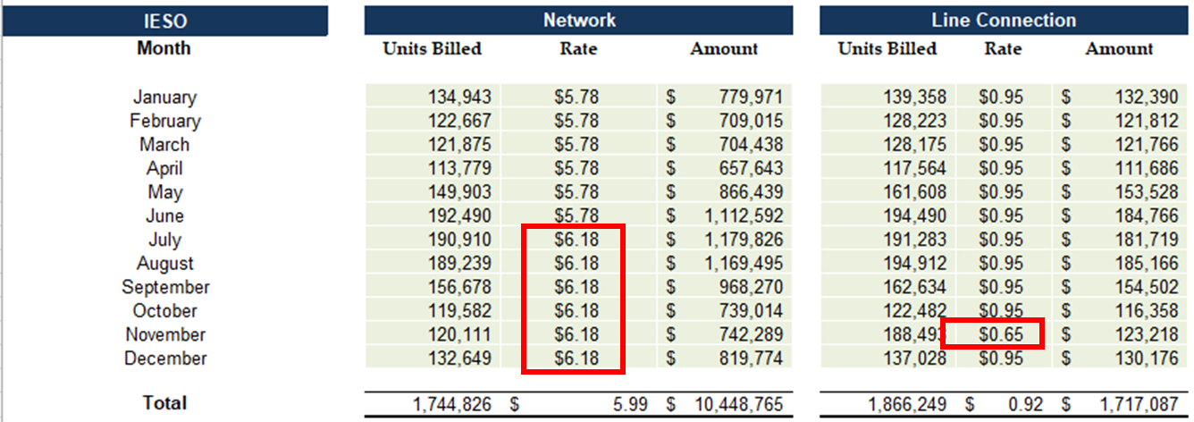

Snapshot from Tab 11:

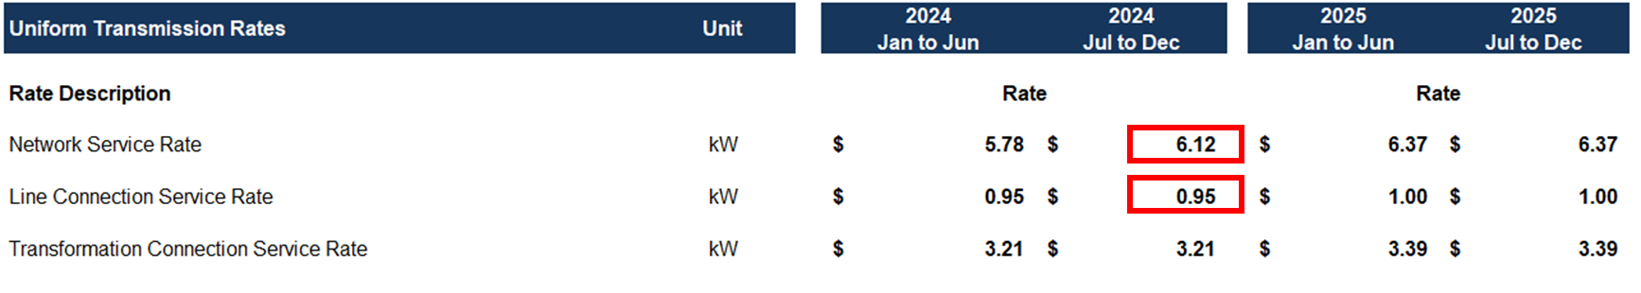

**Question(s):**

1. Please provide reasoning for the Network rates from July to December and the Line Connection rate for November not reconciling with the rates reported on Tab 11.

**Staff Question-**

**Ref. 1: 2026 IRM Rate Generator Model_20250808, Tab 20 Final Tariff Schedule**

**Preamble:**

For the Embedded Distributor Service Classification in Ref. 1, the distribution volumetric rate, low voltage service rate and retail transmission rates are only applicable to the Victoria and Rockway installations.

**Question(s):**

1. Please confirm the accuracy and provide an explanation for why these are not applicable to the Wellandport and Port Davidson installations.

**Staff Question-7**

**Question(s):**

1. As applicable, please update the Rate Generator Model to reflect any updated rates / charges (e.g., 2026 Uniform Transmission Rates).