**Lakefront Utilities Inc.**

**EB-2025-0025**

**October 2, 2025**

Please note, Lakefront Utilities Inc. (Lakefront Utilities) is responsible for ensuring that all documents it files with the Ontario Energy Board (OEB), including responses to OEB staff questions and any other supporting documentation, do not include personal information as that phrase is defined in the *Freedom of Information and Protection of Privacy Act*, unless filed in accordance with rule 9A of the OEB’s *Rules of Practice and Procedure*.

**Staff Question-**

**Ref. 1:** 2026_Lakefront_IRM_Application_20250814, pp. 18, Report on Accuracy Improvements in Accounts 1588 and 1589 Compliance

**Preamble:**

In accordance with the OEB’s July 31, 2025 Decision and Rate Order, Lakefront Utilities prepared a report outlining the steps taken to implement effective and adequate controls to ensure accuracy of settlements and balances in Accounts 1588 and 1589.

**Question(s):**

1. Please confirm when additional controls were implemented (e.g. management review/sign-offs, review of formulas, calculation methods and worksheets, variance analysis procedures, reconciliation processes).
2. Please explain how the variance analysis procedures have been enhanced using the Commodity Accounts Analysis Workform and how the procedures strengthen accuracy of monthly settlement amounts. Provide a sample of one month’s variance analysis of Accounts 1588 and 1589, including an explanation for any subsequent adjustments that had to be made.
3. Describe the newly established reconciliation processes mapping RSVA account balances to general ledger accounts and internal records and how the new processes strengthen accuracy of account balances and monthly settlements. Provide a sample of one month’s reconciliation of Accounts 1588 and 1589, including an explanation for any subsequent adjustments that had to be made.

**Staff Question-**

**Ref. 1:** 2026-IRM-Rate-Generator-Model_Lakefront_20250814, Tab 1 Information Sheet

**Ref. 2:** 2026-IRM-Rate-Generator-Model_Lakefront_20251002, Tab 1 Information Sheet

**Preamble:**

The EB Number must match the assigned EB number.

All details in the “pale green cells” represent input cells and should be filled out.

OEB staff has updated the details in Ref. 2 as below:

**Question(s):**

1. Please confirm the accuracy of the updates.

**Staff Question-**

**Ref. 1:** 2026-IRM-Rate-Generator-Model_Lakefront_20250814, Tab 1 Information Sheet

**Ref. 2:** EB-2024-0038, Decision and Rate Order, July 31, 2025

**Preamble:**

In Ref. 1, Question 2 (Cells F32 and F34) should indicate the year that Accounts 1588 and 1589 were last disposed on a final basis.

In Ref. 2, the OEB approved the disposition of Lakefront Utilities’ Group 1 account balances as of December 31, 2023, on a final basis.

Lakefront Utilities has input the year as 2015 in the Rate Generator Model and states in the Manager’s Summary:

*The Account 1588 and 1589 balances in were last approved for disposition, covering the year ended December 31, 2023, on a final basis, as part of LUI’s 2025 IRM Application (EB-2024-0038) on July 31, 2025.*

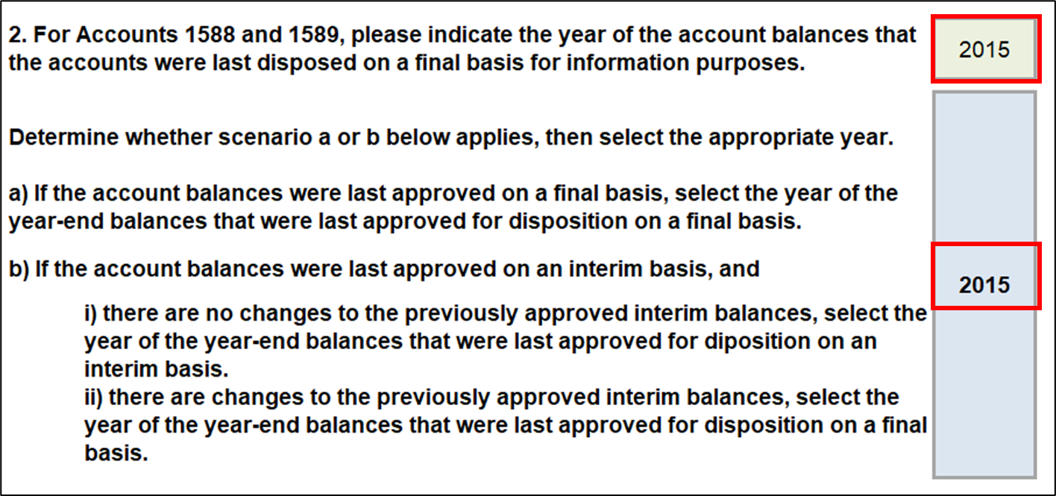

**Question(s):**

1. Please update the values to reflect the correct year that Accounts 1588 and 1589 were last disposed of on a final basis.

**Staff Question-**

**Ref. 1:** 2026-IRM-Rate-Generator-Model_Lakefront_20250814, Tab 2 Current Tariff Schedule

**Preamble:**

Cell BC9 is a drop-down that helps ascertain if the Current Tariff Schedule is accurate. Lakefront Utilities has responded that it has not confirmed the accuracy of the tariff sheet in the Rate Generator Model.

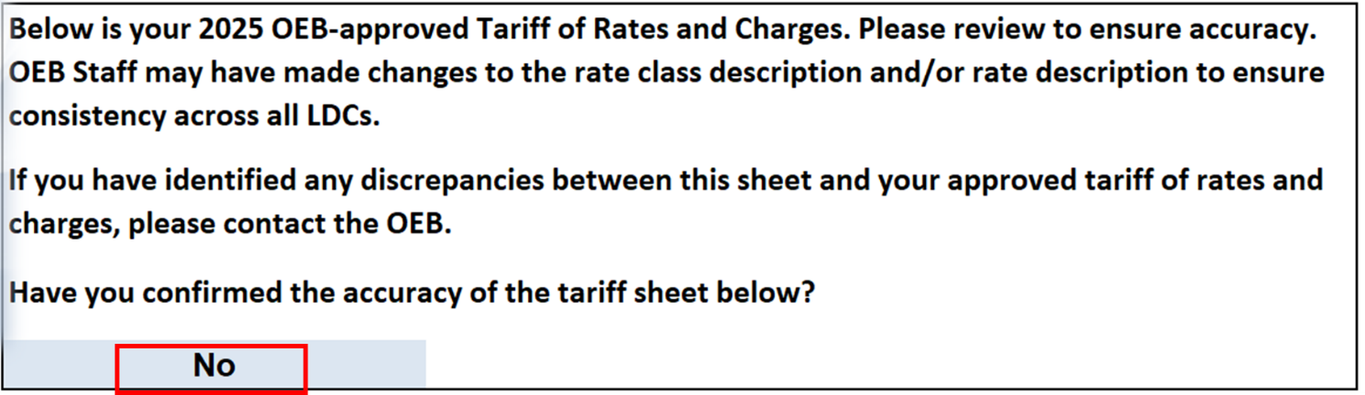

In the Manager’s Summary, Lakefront Utilities states:

*LUI confirms that the tariff of rates and charges is accurate, as included in Tab 2 of the model and confirms the accuracy of the pre-populated billing determinates and customer volume, as included in Tab 4 of the model.*

**Question(s):**

1. Please confirm if Lakefront Utilities has identified any discrepancies in Ref. 1. If there are no discrepancies, please update the drop-down response.

**Staff Question-**

**Ref. 1:** 2026-IRM-Rate-Generator-Model_Lakefront_20250814, Tab 3 Continuity Schedule

**Preamble:**

On September 11, 2025, the OEB published the 2025 Quarter 4 prescribed accounting interest rates applicable to the carrying charges of deferral, variance and construction work in progress (CWIP) accounts of natural gas utilities, electricity distributors and other rate-regulated entities.

**Question(s):**

1. Please confirm that Tab 3 (Continuity Schedule) reflects the Q4 2025 OEB-prescribed interest rate of 2.91%. If not, please update Tab 3, as necessary.

**Staff Question-**

**Ref. 1:** 2026_Lakefront_IRM_Application_20250814, pp. 16

**Preamble:**

In Ref. 1 of the Manager’s Summary, Lakefront Utilities states:

*Lakefront is fully embedded within Hydro One Networks Inc.’s distribution system and is requesting approval to reduce the RTSRs it charges its customers to reflect the rates that it pays for transmission services.*

**Question(s):**

1. Please provide clarification regarding the statement that Lakefront Utilities is requesting approval to reduce the RTSRs as the Proposed (2026) RTSRs are shown to be increasing from the Current (2025) RTSRs.

**Staff Question-**

**Ref. 1:** 2026-IRM-Rate-Generator-Model_Lakefront_20250814

**Ref. 2:** EB-2020-0036, Decision and Rate Order, pp. 7

**Preamble:**

In response to Question 4 (Cell F47) of Tab 1 in Ref. 1, Lakefront Utilities selected 2021 as the earliest account balance vintage year in which there is a balance in Account 1595.

However, in Ref. 2, the OEB directed no disposition of Lakefront Utilities’ Group 1 accounts be made, as the balances did not exceed the disposition threshold.

In Tab 3 of Ref. 1, Lakefront Utilities reported a NIL amount in Account 1595 (2022) for the year 2022, a debit principal adjustment of $475,739 in 2023 and a credit transaction of $286,449 in 2024.

**Question(s):**

1. Please update the response to Question 4 of Tab 1 in Ref. 1, if necessary.
2. Please explain why no amounts were reported in 2022 in Account 1595 (2022).
   1. Please provide supporting calculations for the amounts reported in 2023 and 2024.

**Staff Question-**

**Ref. 1:** 2026_Commodity_Accounts_Analysis_Workform_2.0_20250814

**Preamble:**

In Note 4 of the 2026 Commodity Accounts Analysis Workform, the difference between Lakefront Utilities’ calculated loss factor and the most recent approved loss factor as calculated in Cell K63 is greater than 1%.

**Question(s):**

1. Please file an updated Commodity Accounts Analysis Workform that includes an explanation of the difference in loss factor in Cell F66 of the GA 2024 Tab.

**Staff Question-**

**Ref. 1:** 2026_Commodity_Accounts_Analysis_Workform_2.0_20250814

**Ref. 2:** 2026-IRM-Rate-Generator-Model_Lakefront_20250814, Tab 3 Continuity Schedule

**Preamble:**

In Note 5 of Ref. 1, a credit of $126,471 is reported as the recovery in CT142 in 2025 related to 2024 settlement. This amount is also included in the Principal Adjustment Tab.

OEB staff further notes that there is NIL principal adjustment reported in Account 1589 for 2024 in Ref. 2.

**Question(s):**

1. Please clarify why the recovery in CT142 of a credit $126,471 is reported in Account 1589.
2. Please explain what the principal adjustment consists of and the pertaining month where this settlement is related to.
3. Please provide updated Ref. 1 and/or Ref. 2 to ensure that the principal adjustments reported in both references are reconciled, if necessary.

**Staff Question-**

**Ref. 1:** 2026_Commodity_Accounts_Analysis_Workform_2.0_20250814, Tab Account 1588

**Ref. 2:** 2026-IRM-Rate-Generator-Model_Lakefront_20250814, Tab 3 Continuity Schedule

**Ref. 3:** EB-2024-0038, Lakefront Utilities DVA Inspection Report, May 5, 2025

**Preamble:**

In Note 7a of Ref. 1, a credit of $405,011 is reported as the 1588-1589 OEB Audit. This amount is also included in the Principal Adjustment Tab, but under the description “CT 148 true-up of GA Charges based on actual RPP volumes”.

OEB staff further notes that there is NIL principal adjustment reported in Account 1588 for 2024 in Ref. 2.

**Question(s):**

1. Please clarify what the credit principal adjustment of $405,011 relates to.
2. Please provide listing of all the principal adjustments related to the OEB Inspection in Ref. 3 by accounts.
3. Please reconcile the principal adjustments provided in response to the previous question with those as reported in Ref. 2 and 3.
4. For any 2024 principal adjustments not mapped to the OEB Audit, please provide detailed calculations.
5. Please provide updated Ref. 1 and/or Ref. 2 to ensure that the principal adjustments reported in both references are reconciled, if necessary.

**Staff Question-**

**Ref. 1:** 2026-IRM-Rate-Generator-Model_Lakefront_20250814, Tab 3 Continuity Schedule

**Ref. 2:** EB-2024-0038, Decision and Rate Order, 2025 IRM Rate Generator Model, July 31, 2025

**Preamble:**

In Ref. 1, a debit of $172,592 is reported as the closing principal balance as of December 31, 2023 for Account 1589. This amount differs from the 2023 closing principal balance of a debit amount of $174,683, as reported in Ref. 2.

**Question(s):**

1. Please provide the updated Continuity Schedule reflecting the correct 2023 closing principal balance for Account 1589.

**Staff Question-**

**Ref. 1:** 2026_Commodity_Accounts_Analysis_Workform_2.0_20250814, Tab GA 2024 Note 2

**Preamble:**

In Ref. 1, Lakefront Utilities has input the 2024 Consumption for “Total Metered excluding WMP” as 236,611,529.

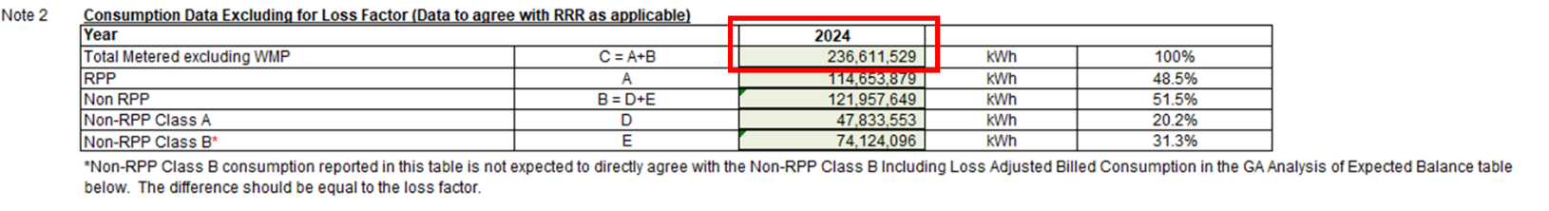

**Question(s):**

1. Please confirm if this is correct consumption data as it does not reconcile with the RRR data as was provided.
   1. If the data is correct, please provide the source for the information.
   2. If not, please update as appropriate.

**Staff Question-**

**Question(s):**

1. In the instance the OEB releases any updated rates/charges (e.g., 2026 Uniform Transmission Rates) before Lakefront Utilities provides its responses to OEB staff’s questions, please update the Rate Generator Model, as applicable, and identify the rates/charges that were updated.