RENFREW HYDRO INC.
2026 IRM APPLICATION
EB-2025-0011
Applicant’s Responses to OEB Staff Questions



Renfrew Hydro Inc.
B-499 O’Brien Road
Renfrew, ON K7V 3Z3
P-613-432-4884 F-613-432-7463

Renfrew Hydro Inc. (RHI)
OEB Staff Questions
EB-2025-0011

Please note, Renfrew Hydro is responsible for ensuring that all documents it files with the OEB, including responses to OEB staff questions and any other supporting documentation, do not include personal information (as that phrase is defined in the Freedom of Information and Protection of Privacy Act), unless filed in accordance with rule 9A of the OEB’s Rules of Practice and Procedure.
Staff Question – 1
Reference: 2026 IRM Application PDF, page 16 of 67
Preamble:
The balance of RHI’s Group 1 Deferral and Variance accounts total ($27,090) or ($0.0003) per kWh. RHI is electing to dispose of the Group 1 account balances even though the balance is below the threshold. This annual systematic disposal approach will mitigate inter-generational inequities and prevent the accumulation of large individual account balances. The default disposition period of one year has been used to calculate the rate riders.
Question(s):
- Please provide additional reasoning for the request for Group 1 DVA accounts disposal.

Renfrew Hydro Inc. - Response:

As mentioned above, Renfrew Hydro Inc. (RHI) believes an annual systematic disposal approach mitigates inter-generational inequities and prevents the accumulation of large individual account balances. There are additional reasons:

- In RHI’s 2020 IRM application (EB-2019-0065), the threshold test was also not met, with a total Group 1 credit balance of ($36,457). OEB Staff asked if RHI would be willing to dispose of the balance to avoid inter-generational inequities since there were three years of undisposed balances. RHI agreed with the approach and disposed of the balances. RHI found that disposing of these account balances each year makes the process efficient, more predictable, and transparent.

- RHI also believes it is best to dispose of balances annually, where practical, because not all account balances and resulting rate riders affect all customers. An example is the balance in RSVA – Global Adjustment. The balance in this account is a debit of $93,345 and the resulting rate rider of $0.0033 per kWh, which exceeds the threshold, but only affects Non-RPP customers.

- While RHI agrees the total of Group 1 accounts does not exceed the threshold, however, if analyzing the effects separately for RPP and Non-RPP customers, the threshold is exceeded for each group. If these balances continue to grow for each group in a similar manner, this could result in significant impacts to both groups in a single year once the total threshold has been exceeded. RHI believes both groups should be looked at individually to avoid larger accrued balances over multiple years.

- Please provide the alternative bill impact without the proposed disposition of the Group 1 account balances.

Renfrew Hydro Inc. - Response:

The table below summarizes the alternative bill impacts without the disposition of the Group 1 account balances. RHI has also included the original proposed bill impacts with the disposition of the Group 1 accounts to make the comparison more convenient.

Summary of Monthly Bill Impacts WITHOUT the Disposition of Group 1 Account Balances
 |  |  |  | 2026 Proposed
Rate Class | Usage |  | Current Rates | Rates Total Bill | $ | %
Rate Class | kWh | kW | Total Bill | WITHOUT Disposition | Difference | Difference
Residential - RPP | 750 |  | 133.55 | 136.52 | 2.96 | 2.22%
Residential - non-RPP | 750 |  | 207.64 | 209.12 | 1.48 | 0.72%
Residential - RPP - 10th percentile | 292 |  | 71.37 | 74.15 | 2.79 | 3.91%
Residential - non-RPP - 10th percentile | 292 |  | 102.58 | 105.00 | 2.43 | 2.37%
GS<50 kW - RPP | 2,000 |  | 346.00 | 352.76 | 6.77 | 1.96%
GS <50 kW - non-RPP | 2,000 |  | 542.69 | 545.37 | 2.68 | 0.49%
GS 50 to 4,999 kW | 86,467 | 208 | 20,583.10 | 20,487.28 | (95.81) | -0.47%
Unmetered Scattered Load | 629 |  | 174.28 | 175.47 | 1.19 | 0.68%
Street Lighting | 32,493 | 90 | 11,367.11 | 11,653.65 | 286.53 | 2.52%

Summary of Monthly Bill Impacts WITH the Disposition of Group 1 Account Balances
 |  |  |  | 2026 Proposed
Rate Class | Usage |  | Current Rates | Rates Total Bill | $ | %
Rate Class | kWh | kW | Total Bill | WITH Disposition | Difference | Difference
Residential - RPP | 750 |  | 133.55 | 135.47 | 1.91 | 1.43%
Residential - non-RPP | 750 |  | 207.64 | 210.73 | 3.09 | 1.49%
Residential - RPP - 10th percentile | 292 |  | 71.37 | 73.75 | 2.38 | 3.33%
Residential - non-RPP - 10th percentile | 292 |  | 102.58 | 105.63 | 3.05 | 2.98%
GS<50 kW - RPP | 2,000 |  | 346.00 | 349.96 | 3.97 | 1.15%
GS <50 kW - non-RPP | 2,000 |  | 542.69 | 549.67 | 6.98 | 1.29%
GS 50 to 4,999 kW | 86,467 | 208 | 20,583.10 | 20,678.78 | 95.68 | 0.46%
Unmetered Scattered Load | 629 |  | 174.28 | 176.89 | 2.61 | 1.50%
Street Lighting | 32,493 | 90 | 11,367.11 | 11,735.90 | 368.79 | 3.24%
Staff Question – 2
Reference: 2026 IRM Rate Generator Model Excel, “Billing Det. For Def-Var” tab 4
Preamble:
In the refence above, RHI provides the Proportion of 1595 Recovery for vintage year 2022. OEB staff notes that the vintage year 2022 was not used.
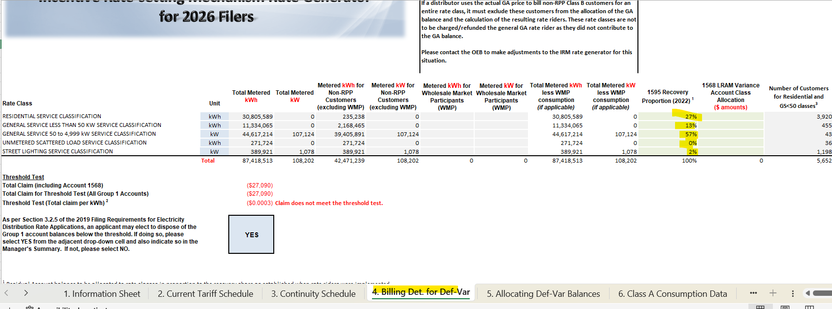
Question(s):
- Please clarify what the allocation proportion is based on.

Renfrew Hydro Inc. - Response:

RHI confirms that the proportion of 1595 Recovery for the vintage year 2022 was used. Please find below the calculations, which include the GA and WMS-CBR accounts.

EB-2021-0055
Allocation of Group 1 Accounts (including Account 1568) |  |  |  |  |  |  |  |  |  |  | GA | WMS-CBR | TOTAL
 |  |  |  |  |  |  |  |  |  |  | From | From | of Group 1
 | From 2022-IRM Rate Generator Model, Tab 5.- Allocating Def-Var Balances |  |  |  |  |  |  |  |  |  | Tab 6.1-GA | Tab 6.2-CBR B | Disposal
 | % of Total kWh | % of Total non-RPP kWh | % of Customer Numbers ** | % of Total kWh adjusted for WMP |  |  | allocated based on Total less WMP |  |  | allocated based on Total less WMP |  |  | Agrees with Tab. 3 - Continuity Schedule. EB-2021-0055 | Percentage of Total Group 1 Disposal
Rate Class |  |  |  |  | 1550 | 1551 | 1580 | 1584 | 1586 | 1588 | 1589 | 1580-Sub | Agrees with Tab. 3 - Continuity Schedule. EB-2021-0055 | Percentage of Total Group 1 Disposal
RESIDENTIAL SERVICE CLASSIFICATION | 36.6% | 1.0% | 89.5% | 36.6% | 38,453 | (233) | (22,422) | (9,766) | 3,162 | (33,577) | ($468) | ($4,840) | ($29,692) | 27.31%
GENERAL SERVICE LESS THAN 50 KW SERVICE CLASSIFICATION | 14.4% | 5.7% | 10.5% | 14.4% | 15,138 | (27) | (8,827) | (3,845) | 1,245 | (13,219) | ($2,664) | ($1,905) | ($14,104) | 12.97%
GENERAL SERVICE 50 to 4,999 kW SERVICE CLASSIFICATION | 47.4% | 90.0% | 0.0% | 47.4% | 49,828 | 0 | (29,056) | (12,655) | 4,098 | (43,511) | ($26,717) | ($4,218) | ($62,231) | 57.23%
UNMETERED SCATTERED LOAD SERVICE CLASSIFICATION | 0.3% | 0.6% | 0.0% | 0.3% | 278 | 0 | (162) | (71) | 23 | (243) | ($259) | ($35) | ($469) | 0.43%
STREET LIGHTING SERVICE CLASSIFICATION | 1.3% | 2.7% | 0.0% | 1.3% | 1,333 | 0 | (777) | (338) | 110 | (1,164) | ($1,240) | ($168) | ($2,245) | 2.06%
Total |  |  |  |  | 105,030 | (260) | (61,245) | (26,675) | 8,637 | (91,714) | (31,348) | (11,166) | (108,740) | 100%

- Please verify and update the 1595 Recovery Proportion, as necessary.

Renfrew Hydro Inc. - Response:

RHI did not update the 1595 Recovery Proportion.

Staff Question – 3
Reference: RRR data submitted by RHI
Preamble:
OEB staff was notified via email by RHI for submitting errors in the RRR that will be corrected and have an impact on its Rate Generator Model.
Question(s):
- Please verify that RHI’s RRR data matches the RRR data contained in its 2026 IRM Rate Generator Model. If not, please update the model if necessary.

Renfrew Hydro Inc. - Response:

RHI confirms that an error was discovered in the RRR data when first populating the Continuity Schedule within the IRM model. RHI contacted the OEB and revised the RRR value and OEB staff updated the model to reflect the change. The correction/revision related to the Sub-Account CBR Class B which was incorrectly entered as a debit and should have been a credit. Before the correction, a RRR variance populated in Tab 3. Continuity Schedule for the Group 1 Account – “Variance WMS – Sub-account CBR Class B.” RHI confirms RRR data, and the data contained in the IRM Rate Generator Model match and are correct.

Staff Question – 4
Reference: 2026 IRM Rate Generator Model Excel, “Continuity Schedule” tab 3
Preamble:
On September 11, 2025, the OEB published the 2025 Quarter 4 prescribed accounting interest rates applicable to the carrying charges of deferral, variance and construction work in progress (CWIP) accounts of natural gas utilities, electricity distributors and other rate-regulated entities.

Question(s):
- Please confirm that Tab 3 (Continuity Schedule) reflects the Q4 2025 OEB-prescribed interest rate of 2.91%. If not, please update Tab 3, as necessary.
Renfrew Hydro Inc. - Response:

RHI confirms the OEB prescribed interest rate of 2.91% for Q4 2025 was used in Tab 3 (Continuity Schedule). RHI used 2.91% in its calculations as a placeholder until the rate was published due to the Q3 rate being 2.91%. Since the rate did not change for Q4 no adjustment is necessary.

Staff Interrogatory – 5
Question(s):
- In the instance the OEB releases any updated rates/charges (e.g., 2026 Uniform Transmission Rates) before RHI provides its responses to OEB staff’s questions, please update the Rate Generator Model, as applicable, and identify the rates/charges that were updated.

Renfrew Hydro Inc. - Response:

The OEB has issued and RHI has updated the preliminary UTR’s and proposed Hydro One ST RTSR’s in the attached updated rate generator. RHI confirms these are the only adjustments made in the attached updated IRM rate generator.

