Fort Frances Power Corporation
EB-2025-0038
December 11, 2025
Please note, Fort Frances Power Corporation (FFPC) is responsible for ensuring that all documents it files with the OEB, including responses to OEB staff questions and any other supporting documentation, do not include personal information as that phrase is defined in the Freedom of Information and Protection of Privacy Act, unless filed in accordance with rule 9A of the OEB’s Rules of Practice and Procedure.
Staff Question-1
Ref 1: IRM Rate Generator Model, Tab 3
Preamble:

On December 10, 2026, the OEB published the 2026 Quarter 1 prescribed accounting interest rates applicable to the carrying charges of deferral, variance and construction work in progress (CWIP) accounts of natural gas utilities, electricity distributors and other rate-regulated entities.

Question(s):
- Please update Tab 3 (Continuity Schedule) as necessary to reflect the Q1 2026 OEB-prescribed interest rate of 2.55%.

Staff Question-2
Ref 1: 2026 Rate Generator Model, Tabs 11, 15 and 20
Ref 2: OEB Letter, EB-2025-0232, 2026 Preliminary Uniform Transmission Rates and Hydro One Sub-Transmission Rates, October 9, 2025

Preamble:

On October 9, 2025, the OEB issued a letter regarding 2026 Preliminary Uniform Transmission Rates (UTRs) and Hydro One Sub-Transmission Rates. The OEB determined the use of preliminary UTRs to calculate 2026 Retail Service Transmission Rates (RTSRs) to improve regulatory efficiency, allowing for this data to feed into the rate applications including annual updates for electricity distributors on a timelier basis. The OEB also directed distributors to update their 2026 application with Hydro One Network Inc.’s (HONI) proposed host RTSRs.

OEB staff has updated FFPC Rate Generator Models with the preliminary UTRs and proposed host RTSR by HONI as follows:

Table 1: Updated Uniform Transmission Rates FFPC Continuity

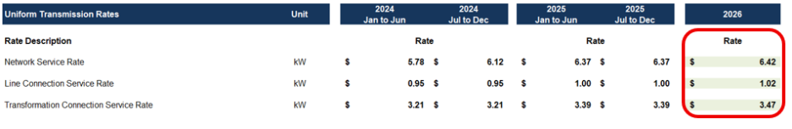

Table 2: Updated HONI Sub-Transmission Rates
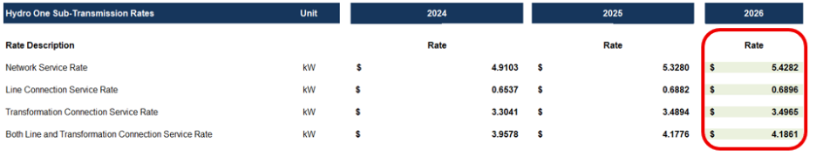

Question(s):

- Please confirm the accuracy of the Rate Generator Model update, as well as the accuracy of the resulting RTSR following these updates.

Staff Question-3
Ref 1: 2026 Rate Generator Model, Tab 18

Preamble:

Effective November 1, 2025, the Time-of-Use RPP prices and percentages were updated as noted in Table 1 below. In addition, the Ontario Electricity Rebate was changed to 23.5%.

Table 1: Updated Time of Use RPP Prices
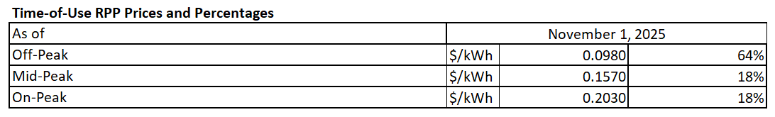
On December 11, 2025, the OEB established an updated Capacity Based Recovery and Rural and Remote Electricity Rate Protection rates of $0.0006.

Question(s):
- The Rate Generator Model was updated to reflect the updated values established in References 1. Please confirm the accuracy of the Rate Generator Model update, as outlined below.

Staff Question-4
Ref 1: 2026 IRM Rate Generator Model, Tab 3
Ref 2: Chapter 3 - Filing Requirements For Electricity Distribution Rate Application, June 19, 2025

Preamble:

As per Reference 2, for the May 1 rate year, if 2021 rate riders expire on the following year April 30, 2022, the balance of sub-account 1595 (2021) is eligible to be disposed after the account balance as of December 31, 2024 which is two years after the rate riders’ expiration has been audited. Therefore, sub-account 1595 (2021) would be eligible for disposition in the 2026 rate year.

Question(s):
- On Tab 3 of the Rate Generator Model FFPC has selected not to dispose of 1595 (2021). Please explain why FFPC does not want to dispose of this balance or update the Rate Generator Model to dispose of this balance.

