Hydro 2000 Inc. (H2000)
EB-2025-0032
December 17, 2025
Please note, Hydro 2000 Inc. (H2000) is responsible for ensuring that all documents it files with the OEB, including responses to OEB staff questions and any other supporting documentation, do not include personal information as that phrase is defined in the Freedom of Information and Protection of Privacy Act, unless filed in accordance with rule 9A of the OEB’s Rules of Practice and Procedure.
Staff Question-1
Reference: 2026 IRM Manager Summary, 10.1 Review and Disposition of Group 1
DVA, page 12
Preamble:
In the reference above “…H2000 is seeking approval to dispose of its Group 1 Deferral and Variance Accounts over a default 12-month period.”

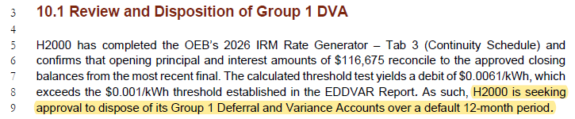
Question(s):
- Please confirm if H2000 has elected to dispose of its Group 1 account balances on an interim of final basis.
H2000 Response: H2000 is seeking a disposition on a final basis.
Staff Question-2
Reference: 2026 IRM Manager Summary, 10.4 Commodity Accounts 1588 and 1589,
page 12
Preamble:
In the reference, H2000 states that “Accounts 1588 and 1589 were disposed on a final basis as part of IRM application EB-2024-0030, for balances up to December 31, 2024.”

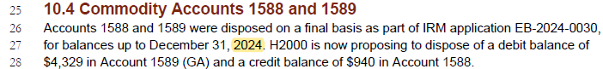
Question(s):
- Please confirm if the disposed balances, as part of H2000’s Cost of Service (EB-2024-0030), for Accounts 1588 and 1589 were up to December 31, 2024, or December 31, 2023.
H2000 Response: H2000 confirms that the evidence was erroneous and that the DVA balances as approved in the EB-2024-0030 were for balances ending December 31. 2023.

Staff Question-3
Reference 1: 2026 IRM Rate Generator Model Excel, “Continuity Schedule” tab 3, cell
BD28
Reference 2: 2026 IRM Commodity Worksheet Excel, “Account 1588” tab 3, cell C20
Preamble:
In both references, Account 1588 reflects two different values: cell BD28 ($1,140) and cell C20 ($1,223).
Question(s):
- Please review the Account 1588 amounts and provide an explanation as to why the values differ. As necessary, please update the Rate Generator Model and Commodity Accounts Analysis Workform.
H2000 Response: H2000 confirms that the information in Tab 3 is consistent with the financial statements and RRR 2.1.7; therefore, the discrepancy of $83 or (0.0002%) of the overall total is indeed in the commodity worksheet. The file has been updated and submitted along with these responses.

Staff Question-4
Reference: 2026 IRM Rate Generator Model Excel, “Continuity Schedule” tab 3,
column BR
Preamble:
On December 10, 2025, the OEB published the 2026 Quarter 1 prescribed accounting interest rates applicable to the carrying charges of deferral, variance and construction work in progress (CWIP) accounts of natural gas utilities, electricity distributors and other rate-regulated entities.
Column BR description reads “Project Interest from Jan 1, 2025 to Apr 30, 2025…”

Question(s):
- Please confirm that Tab 3 (Continuity Schedule), column BR, reflects the Q1 2026 OEB Prescribe interest rate of 2.55%. If not, please update Tab 3, as necessary.
H2000 Response: The interest rate calculations in the model have been updated to reflect the Q1, 2026 rates.

- Please update the description for column BR to reflect the years accordingly. It should read “…Jan 1, 2026 to Apr 30, 2026…”
H2000 Response: The worksheet is protected and, as such, it is and has always been the responsibility of OEB Staff to either provide a functioning model or to interpret the model as applicable to each utility’s circumstances. Since the inception of the IRM mechanism, utilities have not been required to update or modify model headings, including date descriptors.

Staff Question-5
Reference: 2026 IRM Rate Generator Model Excel, “Regulatory Charges” tab 18,
RRRP and WMS Rates effective January 1, 2026.
Preamble:
As per its Decision and Order, dated December 11, 2025, EB-2025-0299, the OEB set the Rural or Remote Electricity Rate Protection (RRRP) and Wholesale Market Services (WMS) charges, effective January 1, 2026.
OEB staff has updated the RRRP and CBR charges in the 2026 IRM Rate Generator Model as per reference above accordingly.
Queston(s):
- Please review and confirm that OEB staff correctly updated the RRRP and CBR charges.
H2000 Response: Confirmed

Staff Question-6
Reference: 2026 IRM Rate Generator Model Excel, “Billing Det. For Def-Var” tab 4,
cell J4.
Preamble:
In the above reference, H2000 is asked to confirm the accuracy of the data provided for the rate classes in this tab. H2000 has not identified ‘Yes’ or ‘No’ for this question.
Queston(s):
- Please confirm if H2000 has confirmed the accuracy of the data reported in tab 4.
H2000 Response: Hydro 2000 confirms the accuracy of the data in Tab 4. The model has been updated accordingly.

