E.L.K. Energy Inc.
EB-2025-0047
January 30, 2026
Please note, E.L.K. Energy Inc. (E.L.K. Energy) is responsible for ensuring that all documents it files with the Ontario Energy Board (OEB), including responses to OEB staff questions and any other supporting documentation, do not include personal information as that phrase is defined in the Freedom of Information and Protection of Privacy Act, unless filed in accordance with rule 9A of the OEB’s Rules of Practice and Procedure.
Please note, OEB staff has attached an updated Rate Generator Model as well as Commodity Accounts Analysis Workform. Please use these versions for any updates required.
Staff Question-
Ref. 1: ELK 2026-IRM-Rate-Generator- Model_20260109_updated_20260121, Tab 3 Continuity Schedule

Preamble:
As per the snapshot below from Ref. 1, E.L.K. Energy has not entered any values for Cells BM37 and BN37.
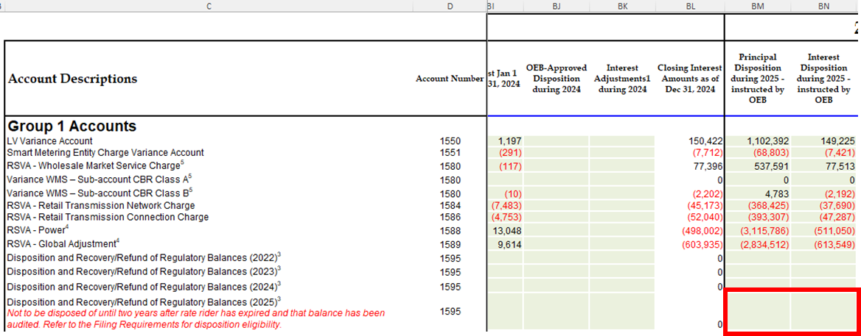
Question(s):
- Please update the Rate Generator Model for Cells BM37 and BN37.

Staff Question-
Ref. 1: ELK 2026-IRM-Rate-Generator- Model_20260109_updated_20260121, Tab 3 Continuity Schedule

Preamble:
The below snapshot is Tab 3 of E.L.K. Energy’s Rate Generator Model. The highlighted text indicates that an explanation of the variance is required. OEB staff notes that there is no explanation of the variance provided by E.L.K. Energy in the Manager’s Summary.
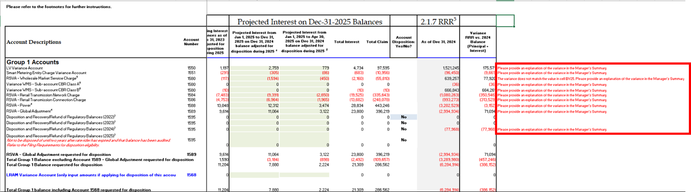

Question(s):
- Please provide an explanation for the variance of each account in Column BW.
- In case the data is correct, please provide the source of the information.
- If not, please update as appropriate.
Staff Question-
Ref. 1: ELK 2026-IRM-Rate-Generator- Model_20260130, Tab 11 RTSR – UTRs & Sub-Tx
Ref. 2: EB-2025-0232, 2026 Uniform Transmission Rates, Schedule A
Ref. 3: EB-2025-0030, Hydro One Networks Inc., Rate Order, Schedule A, p. 11

Preamble:
OEB staff has updated Tab 11 of the Rate Generator Model to reflect the final Uniform Transmission Rates and final Hydro One Networks Inc. sub-transmission rates.
Question(s):
- Please confirm the accuracy of the updated Rate Generator Model.

Staff Question-
Ref. 1: ELK Comm Acct Workform_20261128, Tab GA 2024 Note 2

Preamble:
In Ref. 1, E.L.K. Energy has input the 2024 Consumption for “Total Metered excluding WMP” as 239,605,810 and “RPP” as 131,397,490.
Question(s):
- The above noted values do not reconcile with the RRR data that was provided by E.L.K. Energy.
- Please provide the source of the ‘Total Metered excluding WMP’ and ‘RPP’ values.
- Please explain the discrepancy and update the values, as appropriate.

Staff Question-
Ref. 1: ELK Comm Acct Workform_20261128, Tab GA 2024 Note 4
Ref. 2: ELK Comm Acct Workform_20261128, Tab GA 2024 Cell B65

Preamble:
In Ref. 1, no information has been provided in Cells D41 to E52.
Question(s):
- Please provide an explanation in Note 4(a) (of Ref. 2) for not using unbilled consumption in Ref. 1.

Staff Question-
Ref. 1: ELK Comm Acct Workform_20261128, Tab GA 2024 Cell K62
Ref. 2: ELK Comm Acct Workform_20261128, Tab GA 2024 Cell F66
Ref. 3: ELK 2026-IRM-Rate-Generator- Model_20260109_updated_20260121, Tab 2 Current Tariff Schedule

Preamble:
OEB staff notes that there is a discrepancy in the Loss Factor between Ref. 1 and Ref. 3.

Question(s):
- Please update the Commodity Accounts Analysis Workform and/or Rate Generator Model, as necessary to reconcile the values.
- In case the calculated loss factor persists to be not within +/-1% of E.L.K. Energy’s approved loss factor from the last approved tariff, please provide an explanation in Ref. 2.

