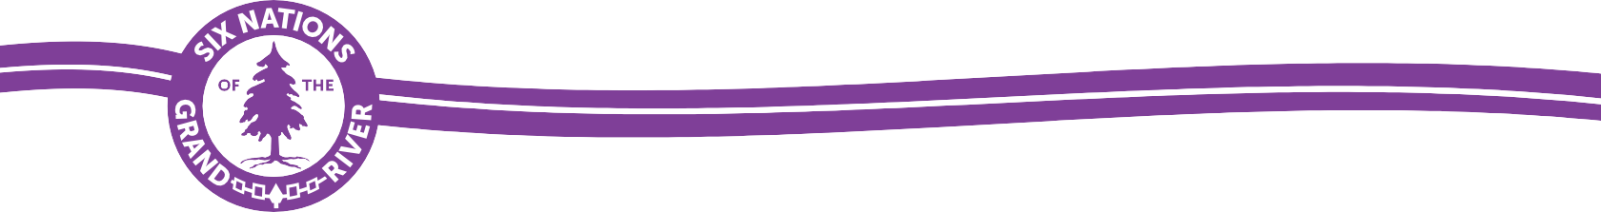

February 2, 2026

Ontario Energy Board
2300 Yonge Street, 27th floor
P.O. Box 2319
Toronto, ON M4P 1E4

Re: Enbridge Gas Inc., Cedar Springs Community Expansion Project, EB-2025-0313

Dear OEB,
The Crown’s duty to consult has not been adequately discharged in respect to EB-2025-0313. We wish to actively participate in the hearing as an Intervenor.
No consultation whatsoever has occurred on this file:
A Notice of Upcoming Project was received on June 6, 2025.
SNGREC requested an introductory meeting on June 9, 2025.
The Draft Cedar Springs ER was received on September 16, 2025. The draft claimed extensive Indigenous consultation had taken place. It also claimed “A Project Description Report was circulated to the Indigenous contact list on July 18, 2025. The report outlined the preliminary findings of natural heritage and cultural heritage and was shared with Indigenous communities to support and facilitate ongoing consultation efforts.”
On September 16, 2025, SNGREC wrote Enbridge, saying there had been no reply to its introductory meeting request, and that the PDR had not been received.
Enbridge replied later that day, confirming the company had failed to send the document to SNGREC: “I tried to attach the Project Description Report and Virtual Information Session material. It came back as undeliverable. This is the same issue that occurred when I emailed you these reports on July 18. I missed that they came back as undeliverable.”
SNGREC responded September 17, 2025, noting “That deadline [for the ER] is unworkable for us as we haven’t even had our introductory meeting yet. Dawn will send potential dates if you’re agreeable.”
On September 22, 2205, Enbridge agreed to an introductory meeting.
Following the above communications, there was some correspondence with SNGREC’s Archaeology Supervisor about field monitoring. There were also frustrating and repetitive conversations about two other Enbridge projects. In that context, it was agreed there’d be an Enbridge-SNGREC meeting about consultation processes prior to discussing individual projects. At that meeting, which occurred on November 25, 2025, Enbridge committed to unspecified capacity funding and an introductory project meeting in the new year for its Cedar Springs project.
As capacity funding has not been formally confirmed or received, we have not read key project documents, and do not fully understand potential impacts to Aboriginal and treaty rights at this time.
Considering the utter lack of consultation as detailed above, we were surprised to learn Enbridge had filed an application for an order exempting the Project from the requirement to obtain leave to construct on November 19, 2025.
The “Indigenous Consultation Report: Summary Tables” claim “SNGR and Enbridge Gas have exchanged emails and met regarding the Project, but that is incorrect. The project was briefly touched on at a November 25, 2025 meeting which occurred after the above statement was submitted.

The Environmental Report submitted as part of that application claims meaningful engagement with affected Indigenous peoples has taken place, but Enbridge has not fulfilled any of the seven responsibilities for procedural consultation with SNGREC as outlined in the Ministry of Energy’s October 19, 2021, letter to the company.

As such an application is clearly premature, we oppose an order being issued.

Sincerely,

Peter Graham
Consultation Supervisor
Six Nations of the Grand River Elected Council

