Wellington North Power Inc.
EB-2025-0003
December 16, 2025
Please note, Wellington North Power Inc. (Wellington North Power) is responsible for ensuring that all documents it files with the Ontario Energy Board (OEB), including responses to OEB staff questions and any other supporting documentation, do not include personal information as that phrase is defined in the Freedom of Information and Protection of Privacy Act, unless filed in accordance with rule 9A of the OEB’s Rules of Practice and Procedure.
Staff Question-
Ref. 1: Wellington North Power_IRM_App_20251028, Sections 15.8.9 and 15.8.10
Ref. 2: Chapter 3 Incentive Rate-Setting Applications, June 19, 2025, p. 15

Preamble:
In Ref. 1, Wellington North Power has requested for disposition of Account 1595 for the rate years 2021 and 2022.
As per Ref. 2,
“For May 1 rate year – If 2021 rate riders expire on the following year April 30, 2022, the balance of sub-account 1595 (2021) is eligible to be disposed after the account balance as of December 31, 2024 which is two years after the rate riders’ expiration has been audited. Therefore, sub-account 1595 (2021) would be eligible for disposition in the 2026 rate year.”
Since the rate rider for Account 1595 (2021) and Account 1595 (2022) expired on April 30, 2023, the rate riders for both rate years would be eligible for disposition in the 2027 rate application.
Question(s):
- Please provide an updated Rate Generator Model without including the disposition of Account 1595 (2021) and Account 1595 (2022).
Staff Question-
Ref. 1: Wellington North Power_2026-IRM-Rate-Generator-Model_V1_20251028, Tab 3 Continuity Schedule
Ref. 2: Dec_Rate Order_Wellington North Power_2024 IRM_20240321, Table 7.1

Preamble:
In Ref. 1, Cell BE36 has a value of (356,689) and Cell BJ36 has a value of 0.
Snapshot (Ref. 1):
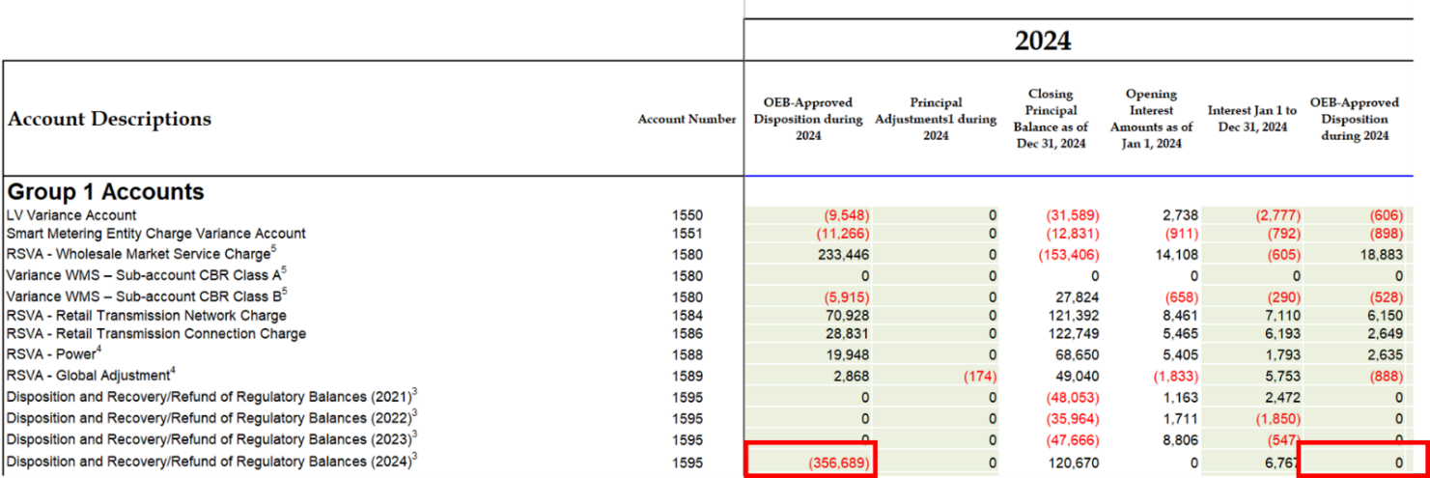

In Ref. 2, the Principal Balance and Interest Balance approved by the OEB are $329,292 and $27,397 respectively.
Question(s):
- Please update the values in Ref. 1 to reflect the values for the Principal and Interest Balances respectively as per Ref. 2.
Staff Question-
Ref. 1: Wellington North Power_2026-IRM-Rate-Generator-Model_V1_20251028, Tab 3 Continuity Schedule

Preamble:
On December 10, 2025, the OEB published the 2026 Quarter 1 prescribed accounting interest rates applicable to the carrying charges of deferral, variance and construction work in progress (CWIP) accounts of natural gas utilities, electricity distributors and other rate-regulated entities.
Question(s):
- Please update Tab 3 (Continuity Schedule) to reflect the Q1 2026 OEB-prescribed interest rate of 2.55%.
Staff Question-
Ref. 1: Wellington North Power_2026-IRM-Rate-Generator-Model_20251216, Tabs 18 and 21

Preamble:
On October 17, 2025, the OEB issued a letter regarding updated Regulated Price Plan (RPP) prices effective as of November 1, 2025. Also, effective November 1, 2025, the Ontario Government’s Ontario Electricity Rebate (OER) was changed to 23.5%. The OEB also set the rates for Rural or Remote Electricity Rate Protection (RRRP) and Capacity Based Recovery (CBR) billed to Class B Customers on December 11, 2025.

OEB staff has updated Wellington North Power’s Rate Generator Model with the updated RRRP, CBR billed to Class B Customers, RPP and OER values as follows:

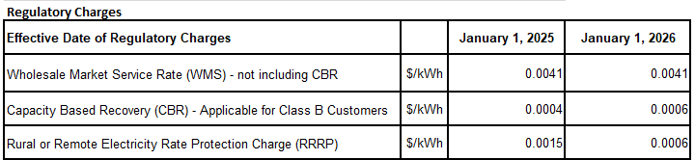

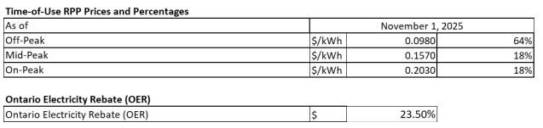

Question(s):
- Please confirm the accuracy of the Rate Generator Model updates.

