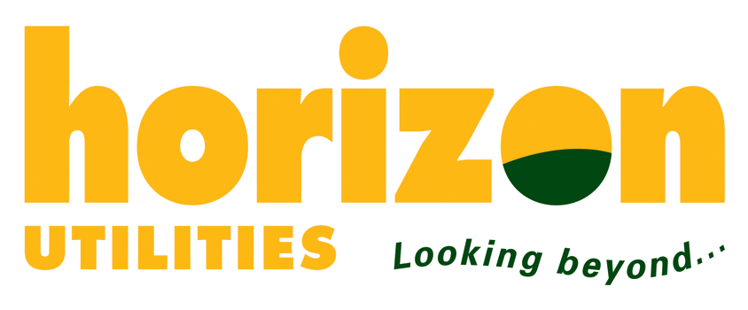

December 8, 2008

Ms. Kirsten Walli
Board Secretary
Ontario Energy Board
2300 Yonge Street
27th Floor
Toronto, ON
M4P 1E4

NOTICE OF INTERVENTION

Re: Combined Proceeding and Notice of Hearing to Examine Outstanding Issues with Respect to Historical Variances Arising from the Recording of Payments In Lieu of Taxes

OEB File No: EB-2008-0381

Horizon Utilities Corporation (“Horizon Utilities”) is requesting intervenor status in the above proceeding.
Horizon Utilities is a licenced electricity distributor in the Province of Ontario and currently maintains a PILs variance account 1562 of which such disposition may be directly impacted by the outcome of this proceeding.
Horizon Utilities may contribute to, and participate in, all matters connected with this proceeding and where it is in Horizon Utilities’ interest or in the interest of the OEB, Horizon Utilities may participate through joint submissions with other distributors.

Horizon Utilities will not be seeking costs in this proceeding.

Please direct all notices, correspondence and copies of all evidence to the undersigned at:

Horizon Utilities Corporation
55 John Street North
Hamilton, Ontario
L8R 3M8

cameron.mckenzie@horizonutilities.com

Yours truly,

Original signed by Cameron McKenzie

Cameron McKenzie,
Director, Regulatory Services

