

WAGE and BENEFIT ANALYSIS

2025

Cornerstone Hydro Electric Concepts Association Ltd.
www.checenergy.ca

September 25, 2025

Table of Contents
Introduction 3
Participating Members 3
Method 4
Confidentiality of Information 4
Disclaimer 4
Remuneration Analysis (Introduction) 5
Remuneration Analysis (Bargaining Unit) 7
Wages 7
Annual Increase in Wages 8
Benefits 9
Remuneration Analysis (Non-Bargaining Unit) 12
Wages 12
Annual Increase in Salary 18
Additional Compensation Elements 19
Benefits 19
Analysis (Other Post Employment Benefits) 20
Benefits 20
Remuneration Analysis (Board) 21
Stipend 21
Per Diem Fees 21
Additional Expenses 21
LDC Demographics 22
Conclusions 23

Introduction
Cornerstone Hydro Electric Concept Association (CHEC) is an association of sixteen Local Distribution Companies (LDCs) that work collaboratively to meet regulatory and operational requirements. The LDC’s covered under this analysis include:

This is the seventh CHEC analysis and report (previously reported in 2011, 2014, 2016, 2018, and 2023) on compensation trends for the CHEC members.
This analysis is designed to provide participating CHEC members a general analysis of the data they submit that may be useful for decision making purposes related to compensation strategies, human resources planning, labour relations, recruitment, and retention, as well as aid in developing effective internal policies and procedures.

Participating Members
All sixteen CHEC members were offered participation in the analysis, and thirteen members chose to participate (to varying degrees).
For the purposes of confidentiality, the participating members are not highlighted in the published report.

Method
In 2023, an input document was developed in collaboration with a number of the participating member LDCs in order to standardize the data being returned.
The input document seeks information related to bargaining unit and non-bargaining unit compensation and related perquisites, early and post retiree benefits, and information related to board remuneration. In addition, the input document seeks some general anecdotal information related to changes since the last wage and benefit report, pressures related to attraction and retention of employees, insights related to bargaining trends, cost of group benefits as a percentage of payroll, and any additional comments the member wishes to share.

Confidentiality of Information
The information collected through this analysis is treated with the utmost confidentiality. To preserve the confidentiality of data supplied by those participating, non-public compensation and benefit details are reported on an aggregate basis only, and where a minimum of three or more organizations data is included in the sample.

Analysis results are reported only to those members who provide data for the report. All participants are asked to consider this report as strictly confidential and are asked not to share the results with any entity that has not participated.

Disclaimer
This analysis is not designed to address every position in your organization. It is intended to cover the most common positions found in most Local Distribution Companies (LDCs) across the CHEC group of LDCs. The selected positions are intended to be benchmarks only and should be treated accordingly.

E&OE

Remuneration Analysis (Introduction)
Members were asked to provide compensation data for various positions in their LDC as outlined in the following table.
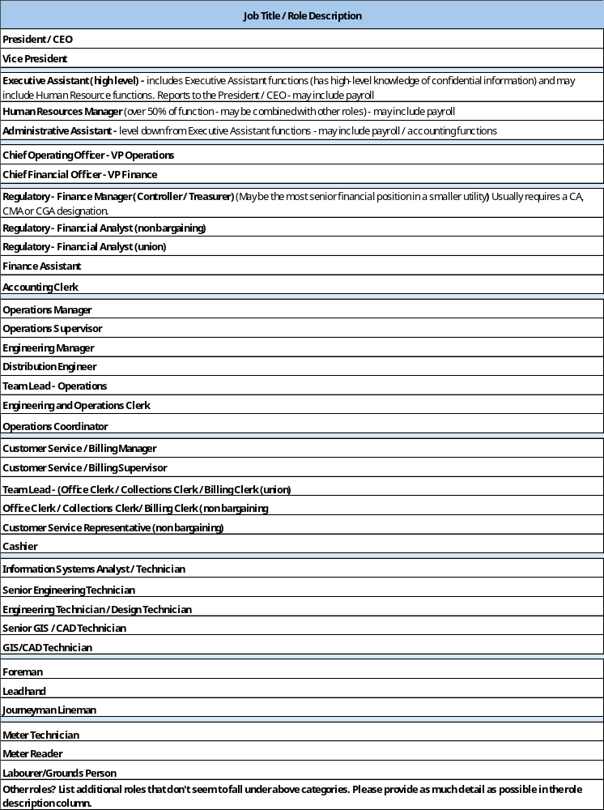

Only those positions where three or more samples were provided are represented in this report.
In addition, when completing the compensation details for each position, members were requested to indicate if the position is unionized or not.
In some cases, a position title is identified as being in the bargaining unit in one LDC and in the non bargaining unit in another LDC.
Examples of such roles (with a minimum of three samples in each category) are:
- Team Lead (Office Clerk/Collections Clerk / Billing Clerk) (three unionized / four non-unionized)
- Customer Service Representative - (six unionized / four non-unionized)

You will note that these positions are covered in both the Bargaining Unit and Non-Bargaining Unit sections of the report.

Remuneration Analysis (Bargaining Unit)
The respondents were asked to indicate how bargaining unit staff is compensated among the LDC’s. The compensation packages are comprised of diverse elements. The following summary provides an overview.

Wages
Wages are captured as the average of the low rate of wage and the average of the high rate of wage for each position identified, with the value being presented as the average rate at December 31, 2025.
Only those positions with three or more samples are represented.
Outside Staff | Sample | Average min rate at December 31 2025 | Average max rate at December 31 2025
Foreperson | 9 |  | $ 53.73
Leadhand | 7 |  | $ 51.52
Journeyperson/ Lineperson | 12 | $ 34.41 | $ 49.04
Meter Technician | 4 | $ 37.61 | $ 49.10
Outside staff work a ‘regular’ 40-hour workweek.

Inside Staff | Sample | Average min rate at December 31 2025 | Average max rate at December 31 2025 | Note
Team Lead( Office Clerk/Collections Clerk/Billing Clerk) | 3 |  | $40.47 | (only one sample given at the min rate)
Accounting Clerk | 5 | $32.61 | $40.81 | (only four samples given for the max rate)
Customer Service Representative | 6 | $30.07 | $36.32 | (only five samples given at the max rate)
Senior Engineering Technician | 3 | $34.99 | $51.18
Engineering Technician / Design Technician | 4 | $33.98 | $48.33 | (only three samples given for the min rate)
Inside staff ‘regular’ work week ranges from 35 to 40 hours per week depending on the LDC.

Most bargaining unit staff positions are based on a progressive scale that considers experience and seniority. The low rate typically represents an entry level or apprentice position, while the high rate typically represents a more senior individual or a fully qualified tradesperson.

Annual Increase in Wages
Since increases in compensation occur at various times during the year, including in some cases occurring at more than one interval, respondents were requested to provide a total percentage annual increase in the year 2025 (i.e., total % increase ‘as at’ December 31, 2025), 2026 and 2027:
In some cases, the outcome of total percentage increase in the year is still unknown at the times of submission and completion of the report.
2025: Increases reported for the bargaining unit in 2025 ranged from 1.30% to 6.00% with an average of 2.98%.
2026: Approximately half of the respondents indicated the values for increases in 2026 – these ranged from 1.30% to 3.00%, with an average of 2.37%.
2027: Not enough samples were provided to give a figure for 2027.

Benefits
Benefits among the LDC’s are comparable with no significant differences. Typical bargaining unit benefits reported are as follows:
Item | Benefit
Hours of Work | Where an inside union is indicated, the majority indicate that the hours of work for inside workers are at 35 hours, a few at 37.5 hours and 40 hours, respectively. Outside workers are all at 40 hours per week.
Overtime | The majority of members pay out overtime at double time, with a few Collective Agreements indicating 1.5 x for certain days of week or within a specified number of hours after regular shift.
On Call / Standby / week | On call is expressed in a few different ways: (i.e. as a per diem, an hourly amount per day (with different rates for specified days of the week), or a weekly amount. Calculated per diem rate range from $225 to $392.
On Call - Call Out Overtime | The majority indicate a minimum of 2 hours and paid for all hours worked.
Standby on Public Holiday | Standby pay on public holidays is provided, with the majority of respondents indicating paying out an additional nominal dollar amount that represents either one to four hours, with a few indicating a full day off in lieu.
Relief Pay | Generally paid at a rate of 105% to 112% (some with caveats that a minimum number of hours or shifts are to be worked in the higher class in order to receive the relief pay).
Banked Time | Majority reflect either 40 to 80 hours allowable for banked time, with some indicating carry forward.
Paid Holidays | Range from 11 to 13 days (this includes 2 x 1/2 days for Christmas Eve and New Years Eve.
Floater Days | Between 1 to 3 days. Note: when adding the floater days and public holidays together, the average combined total of Public Holidays and Float Days amongst LDCs is approximately 13.50 days.
Vacation | Scaled - Most commonly starts at 2 weeks after 1 year with additional weeks being added at approximately 3, 9, 17 and 25 years - generally maxing out at 6 weeks (30 days). Between the upper limit milestone years (i.e. around 17 and 25), some include language to have additional days added per year or every second year.
Winter Vacation Bonus | None noted in 2025.
Mileage | Where indicated, the majority offer CRA rate.
Sick Days | The majority indicate accruing between 1 day and 1.5 days per month.
Short-Term Disability | Typically covers through the elimination period of LTD with some indicating a scale (from 70% to 100%) of payout based on accrued sick days.

Item | Benefit
Long-Term Disability | Premiums are typically covered 100% by Employer: Generally - the range of payment is between 66.7% and 75% of salary - with caps ranging from $3000.00 to $8500.00 / month.
Life Insurance | Premiums are typically covered 100% by Employer: All provide Life Insurance with range of 1.5 to 2x salary and some indicating caps of between $400K to $600K.
Dependent Life Insurance | Where indicated as being offered, benefits are between $1K and $10K for spouse and $1 and $5K for children. (Spouse is typically higher).
Medical | Medical coverage is robust; with typically 100% Employer paid premiums, with only a few indicating dispensing fees / deductibles for parameds, etc.; typically offering semi-private to private and travel assistance as well as vision, hearing, and a range of parameds, etc. Ranges for parameds are from $300 to $850 and increases in mental health related benefits have been occurring in the last couple of years. Health Spending Accounts are becoming more common to provide additional coverages that exceed the caps of the existing group benefit. Employee Assistance Program (EAP) is indicated as being offered in some of the Collective Agreements.
Dental | Dental coverage is robust, covering basic dental procedures and most plans provide for additional coverage for major procedures and orthodontics with varying annual and lifetime cap amounts.
Vision | Range from $350 to $700 / 2 years. (A few have indicated increases to vision since the last report).
Eye Exams | Generally covered with the majority limiting to once every two years.
Safety Vision | Generally covered with limits ranging from $175 to $450 every 2 years.
Leave of Absence in excess of Employment Standards Act, 2000 (ESA) | Some indicate providing Leave of Absence in excess of ESA and in some cases specifically naming such times as additional time for bereavement, utilizing sick time for Dependent Care / Family Leave, birth of child, etc. and in other cases just leaving it open to the discretion of management. Where it is not specifically indicated as being paid, language in the Collective Agreement typically indicates leave without pay.
Pregnancy / Parental Leave | All as per Employment Standards Act (ESA).
Bereavement | The majority offer 5 days of leave for immediate (in home family members) with majority also including parents at this level; 3 days of leave is provided for varying definitions of the broad range extended immediate family (which often includes siblings, steps).etc. and those not living in the immediate home, and 1 day of leave is typically offered for Aunts / Uncles and family once removed. Some allow borrowing from sick bank for additional time, as well as requesting additional days (at discretion).
Jury Duty | All indicate providing full payment (typically less travel and meals, etc.), less amount received from Jury Service).

Item | Benefit
Tools | Typically supplied by LDC.
Clothing | Boot allowances generally range from $250.00 to $400.00 per year. Safety clothing is typically provided as required, and / or reimbursed.
Drivers License / Professional Memberships Association | A few of the LDCs indicate providing some assistance with payment of professional Association fees (i.e. Trade Licenses, OACETT), educational assistance, and payment of certain classes of driver's license. These benefits are not consistent among the group.
Company Vehicle | A couple of the LDCs indicate the foreman (and linemen) drives company truck (and in particular, when on call).
Other | Fitness benefit has been introduced by some in recent years.

Note: Where reported, group benefits premiums ranged between 6.5% to 11.5% of payroll.

Remuneration Analysis (Non-Bargaining Unit)
The respondents were asked to indicate how management is compensated within the LDC’s. The compensation packages are comprised of diverse elements. The following summary provides an overview of the compensation elements for CHEC LDC Non-Bargaining Unit positions.

Wages
Wages are captured as an average of the min rate and an average of the max rate of salary reported for each position identified.
In addition, we have included the averages of each rate expressed as an hourly rate since the number of hours representing the annualized salary differs per LDC (i.e., an annual salary may be based on hours representing anywhere from 35 to 40 hours per week).
Please note - only those positions with three or more common roles reported are being represented. The tables below show the number of samples for each. You will note in some cases that the number of samples do not all add up equally. This means that for some of the samples, the salary reported demonstrated only the minimum or maximum base salary, and in the case of the percentage increases in 2025, this means that for some of the samples, the annual percentage increase was still unknown / or the value was not reported. In these cases, the value for the sample was left as undefined.
In addition, every effort is made to identify and / or remove anomalies within the data (with appropriate comments as applicable).
President / CEO:
(total samples = 12)
One low sample was removed.
Annual max rates ranged from $ 165,000.00 to $ 264,000.00 (rounded to the nearest thousand).
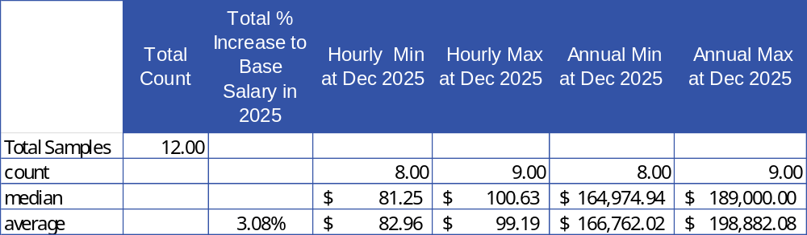

Chief Financial Officer – VP Finance
(total samples = 5)
One low sample was removed.
Annual max rates ranged from $ 140,000.00 to $ 174,000.00 (rounded to the nearest thousand).
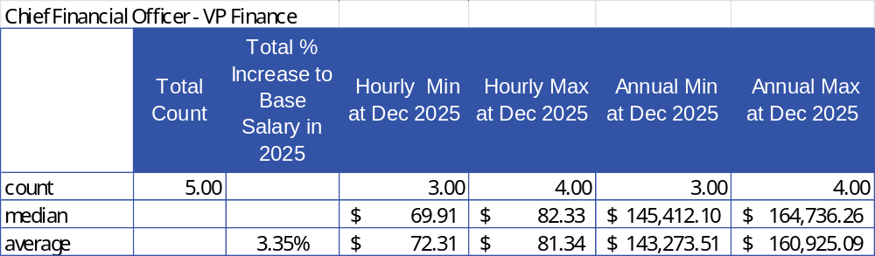

Regulatory – Finance Manager (Controller / Treasurer)
(total samples = 9)
One high sample was removed.
Annual max rates ranged from $ 113,000.00 to $ 145,000.00 (rounded to the nearest thousand).
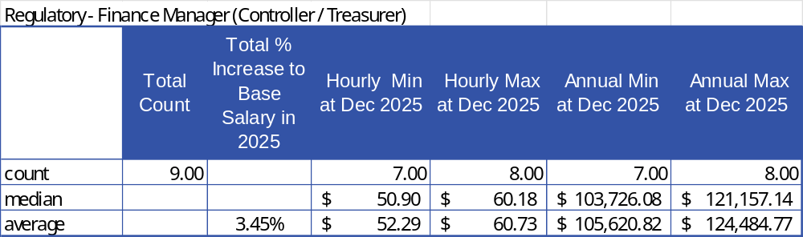

Regulatory / Financial Analyst
(total samples = 6)
One low sample and two high samples were removed.
Annual max rates ranged from $ 89,000.00 to $ 90,000.00 (rounded to the nearest thousand).
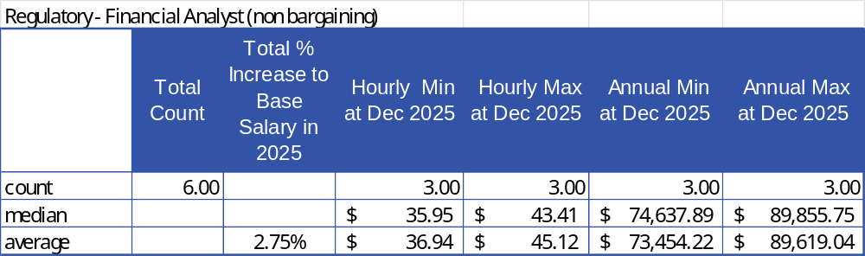

Operations Manager
(total samples = 10)
One high sample was removed.
Annual max rates ranged from $ 122,000.00 to $ 147,000.00 (rounded to the nearest thousand).
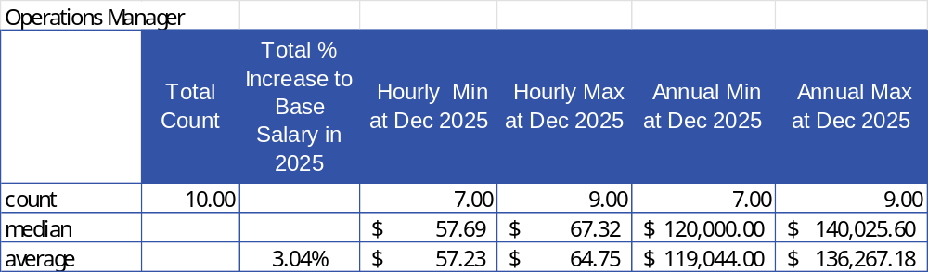

Operations Supervisor
(total samples = 5)
All samples were included.
Annual max rates ranged from $ 114,000.00 to $ 132,000.00 (rounded to the nearest thousand).
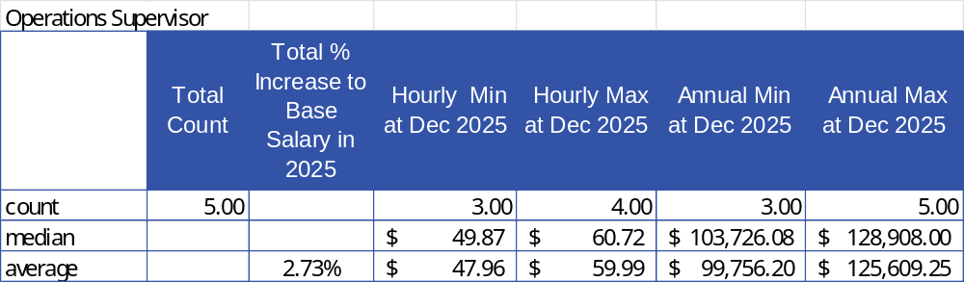

Engineering Manager
(total samples = 4)
All samples were included.
Annual max rates ranged from $ 119,000.00 to $ 143,000.00 (rounded to the nearest thousand).
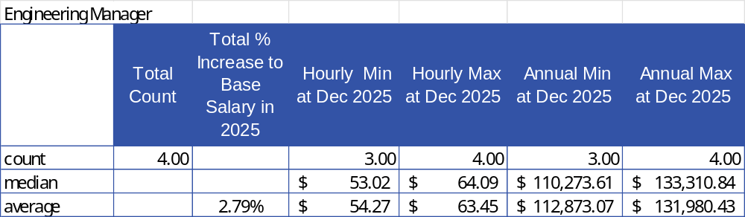

Customer Service / Billing Manager
(total samples = 9)
All samples were included.
Annual max rates ranged from $ 81,000.00 to $ 134,000.00 (rounded to the nearest thousand).
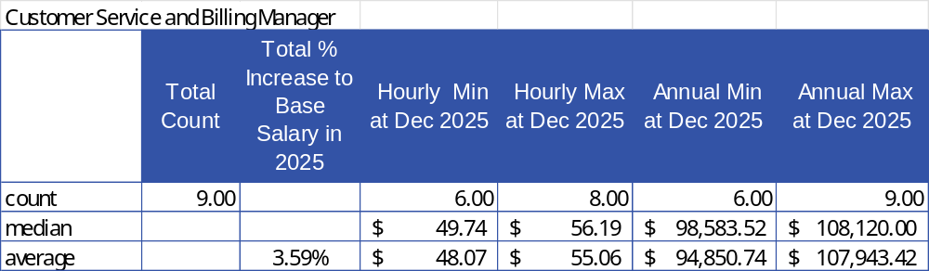

Customer Service / Billing Supervisor
(total samples = 4)
One low sample was removed.
Annual max rates ranged from $ 101,000.00 to $ 114,000.00 (rounded to the nearest thousand).
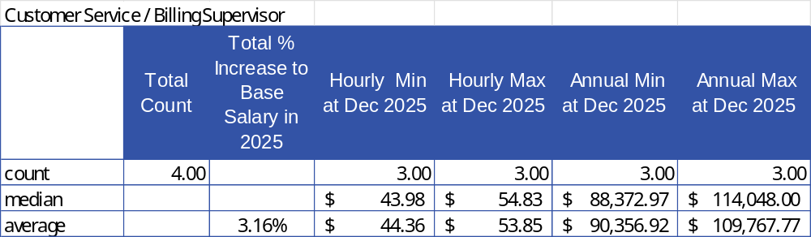

Team Lead (Office Clerk/Collections Clerk/Billing Clerk)
(total samples = 4)
All samples were included.
Annual max rates ranged from $ 78,000.00 to $ 87,000.00 (rounded to the nearest thousand).
Only the highest sample is based on a 40-hour workweek.
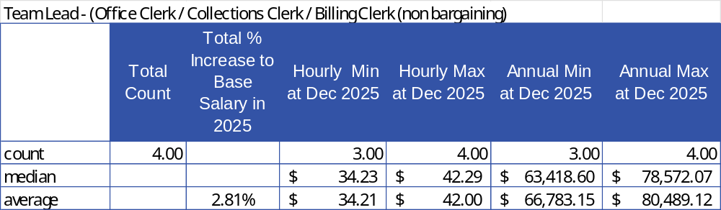

Office Clerk/Collections Clerk/Billing Clerk
(total samples = 3)
All samples were included.
Annual max rates ranged from $ 66,000.00 to $ 78,000.00 (rounded to the nearest thousand).
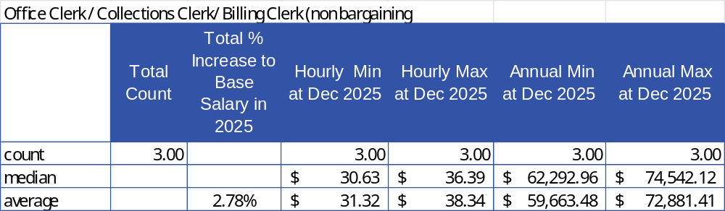

Customer Service Representative
(total samples = 4)
All samples were included.
Annual max rates ranged from $ 57,000.00 to $ 80,000.00 (rounded to the nearest thousand).
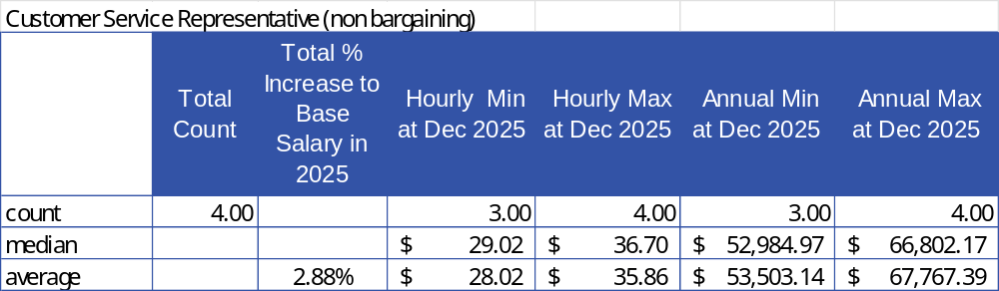

Annual Increase in Salary
Since increases in compensation occur at various times during the year, including in some cases occurring at more than one interval, respondents were requested to provide a total percentage annual increase in the year 2025 (i.e., total % increase ‘as at’ December 31, 2025), 2026 and 2027.
In some cases, the outcome of total percentage increase in the year is still unknown at the times of submission and completion of the report.
2025: Increases reported for the non-bargaining unit ranged from 2.0% to 8.0% and in some cases with different percentage increases being provided for the various non-bargaining unit positions within the LDC.
2026: Not enough samples were provided to give figures for 2026.
2027: Not enough samples were provided to give figures for 2027.

Additional Compensation Elements
In addition to base salary, members were requested to identify if any of their positions receive additional bonuses / variable pay, car allowance, company vehicle, other compensation related incentives, etc.
About half of the respondents’ report providing bonuses to their non-bargaining unit employees. Bonus / variable pay reported ranged from 5% up to 15 % of pay. In some cases, only the Executive positions were reported as having the opportunity to earn bonus / variable pay, and in general these were noted as the higher rates. However, in many cases (where offered) all non-bargaining unit positions were given the opportunity for bonus / variable pay incentives, typically with a scale related to level of position within the LDC.
Car allowances / company vehicles are reported by a few respondents, and typically the positions receiving this perk are the Executive positions and / or those roles with significant travel requirements within their job function.

Benefits
Benefits among the LDC’s are comparable and the Non-Bargaining Unit benefits are generally similar to the Bargaining Unit benefits noted in the preceding section, however a few LDCs report instances of increased vacation entitlement, training and development allowances, club memberships, mobile phone provisions, and some enhancements to group benefit provisions amongst the Non-Bargaining Unit, and in particular the Executive positions.

Analysis (Other Post Employment Benefits)
The respondents were asked to indicate how retirees are compensated among the LDC’s. The following summary provides an overview of the common compensation elements for early retirees among the CHEC group.

Benefits
Other post-employment benefits (OPEBs) refer to the benefits, other than pensions, that an individual employee receives as part of his or her package of retirement benefits. Typically, retiree life insurance is the most significant OPEB offering, though other benefits such as medical and dental benefits are also covered under this umbrella term.
About half of the thirteen respondents reported providing early retirement benefits:
Description | Benefit
Early Retirees | Typically covers the employee between the ages of 55 – 65.  A range of minimum years of service was reported from as few as ten to as many as 30 years of service required.
Pension Plan | OMERS
Other Post-Employment Benefits (OPEBs):
Medical | Medical (Extended Health) coverage can be extended from retirement to the age of sixty-five, employees typically pay 50% of the premium cost to age 65, however a couple have noted 100% employer paid.
Dental | Dental coverage can be extended from early retirement to the age of sixty-five, where offered, employee typically pays 50% of the premium cost to age 65
AD&D | Not typically offered as a post-retirement benefit
Life Insurance | Typically offered at a reduced rate of 50% of salary at retirement with annual reductions thereafter.
Costs | Not enough data was provided to determine this value.

Other Post-Retirement Benefits are intended to bridge the gap between early retirement and the individual reaching the age of sixty-five.
After the age of sixty-five, it is typically expected that various federal and provincial programs will replace OPEBs, and generally speaking, post-retirement benefits (after sixty-fix) are non-existent at most LDCs, however a few do report offering some minimal extended life insurance benefits for those beyond the age of 65.

Remuneration Analysis (Board)
The participants were asked to indicate how Directors are compensated for their contributions to the Board.

Stipend
Twelve of the thirteen members participating provided Board related information.
All submissions were converted to an annual rate.
One sample was removed.
For the majority, two different rates are noted: one for the Board Chair and a second (lower) rate for any other Director (regardless of their role) within the Board.
A few LDCs report a separate rate for the role of Vice Chair.
The following table outlines the annualized rates (rounded to the nearest hundred).
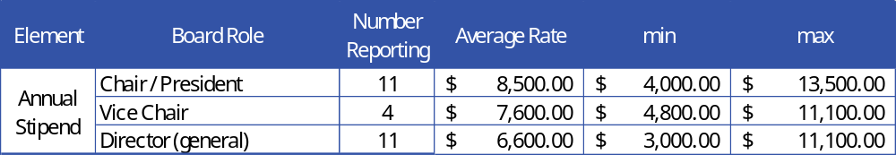

Per Diem Fees
In addition to regular compensation, eight of the twelve reporting LDCs indicate Board Members receive per-diem rates for Board and/or Committee meetings.
The following table outlines the per diem rates (rounded to the nearest 5).
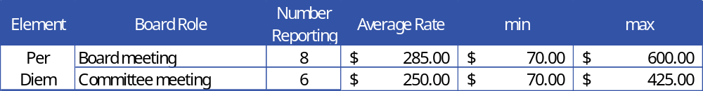

Additional Expenses
Over and above the per diem fees, most of the LDC’s also provide expense reimbursement for industry events, training/conferences, mileage, etc. Most of the LDC’s that cover these expenditures reimburse for true costs, while others report covering costs up to a set maximum per day / event or per year. The majority report reimbursing mileage at the Canada Revenue Agency (CRA) per kilometre rate.

LDC Demographics
For the purposes of confidentiality, the participating LDCs are not listed individually, however the averages are included for informational purposes. (rounded to the nearest fiftieth).

At January 1, 2025
# LDCs participating | Average # Employees Represented | Average #FTEs Represented | Average # Customers | Average Service Area (sq. km)
13 | 22.50 | 21.50 | 11104.50 | 198.00

Conclusions
As noted in the previous year’s reports, and in undertaking ongoing reviews of job posting data and based on input from the additional questions we asked of you in the survey, we know that the capacity to attract and retain employees remains a continued challenge for some of our members.
A focus on Mental Health, Employee Wellness and attraction and retention is evidenced by the various anecdotal comments provided in the survey. Our members demonstrate creativity and responsiveness to employee preferences and needs. Some examples include additions to group benefits including expanded coverage to include psychologist/ mental health practitioner benefits, increases to vision care, more additions to Health Spending Accounts to augment existing group benefits, and fitness benefits.
Remote work continues to be an attractive benefit for many, and while most of the LDC's report mainly in office work, a few allow occasional remote work, and a couple outline specific roles as being designated as hybrid.
A few members had Collective Agreements renew since the last Wage and Benefit report in 2023, and the majority have Collective Agreements expiring in 2026 and 2027. While this report is not designed to provide in depth bargaining related detail, we hope that some of the data provided within this report is helpful to you.
For further information, and/or questions related to the findings of this report, data and trends that may be more specifically relevant to your LDC, please reach out to Tracey Kuusk directly at tkuusk@checenergy.ca.

