Enova Power Corp.
EB-2026-0033
September 29, 2026
Please note, Enova Power Corp. (Enova Power) is responsible for ensuring that all documents it files with the OEB, including responses to OEB staff questions and any other supporting documentation, do not include personal information as that phrase is defined in the Freedom of Information and Protection of Privacy Act, unless filed in accordance with rule 9A of the OEB’s Rules of Practice and Procedure.
Please note, OEB staff has attached an updated Rate Generator Model. Please use this version for any updates required.
Staff Question-
Ref. 1: ENOVA_APPL_2027 IRM_KWRZ_IRM Rate Generator Model_20260929, Tab 3 Continuity Schedule
Ref. 2: ENOVA_APPL_2027 IRM_WNRZ_IRM Rate Generator Model_20260929, Tab 3 Continuity Schedule

Preamble:
On September 14, 2026, the OEB published Q4 2026 prescribed accounting interest rates applicable to the carrying charges of deferral, variance and construction work in progress (CWIP) accounts of natural gas utilities, electricity distributors and other rate-regulated entities.

Question(s):
- Please update Tab 3 (Continuity Schedule) as necessary to reflect the Q4 2026 OEB-prescribed interest rate of 2.87%.

Staff Question-
Ref. 1: ENOVA_APPL_2027 IRM_KWRZ_IRM Rate Generator Model_V2_20260810, Tab 3, Continuity Schedule
Ref. 2: ENOVA_APPL_2027 IRM_WNRZ_IRM Rate Generator Model_V2_20280610, Tab 3, Continuity Schedule
Ref. 3: EB-2025-0045 Decision and Rate Order, pp. 12-15, Tables 7.1 and 7.2

Preamble:
As per snapshot below from Ref. 1, Enova Power has not entered any values for Cells BM37 and BN37.
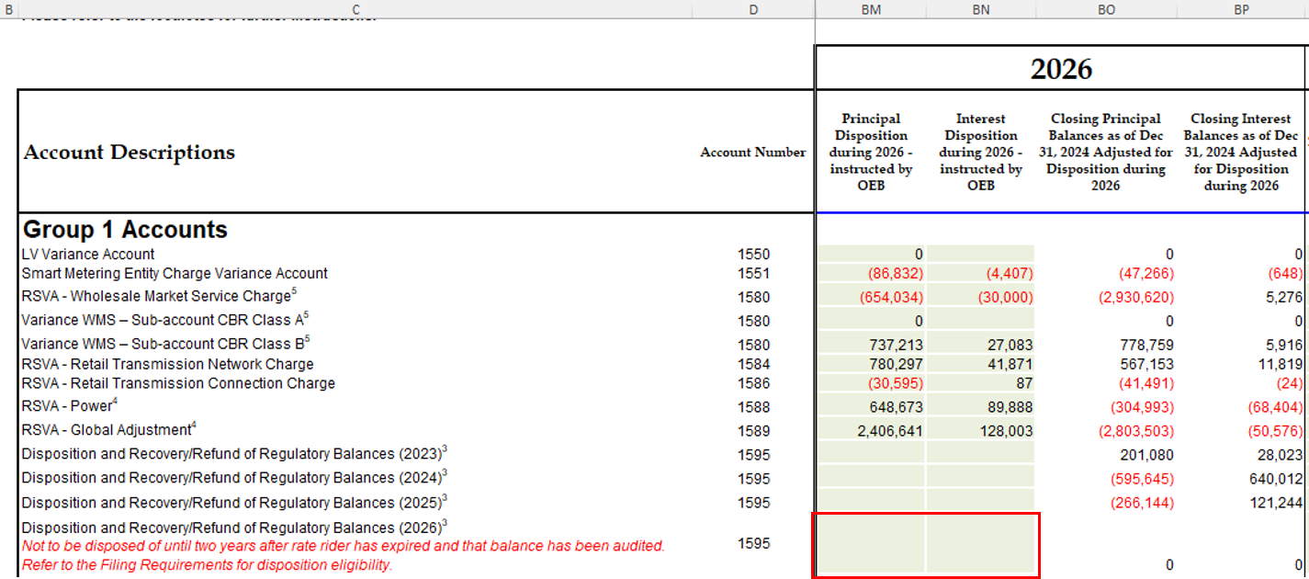

As per snapshot below from Ref. 2, Enova Power has not entered any values for Cells BM37 and BN37.
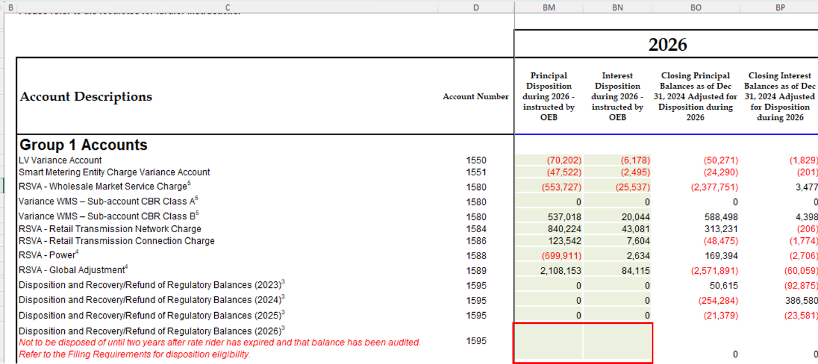

Question(s):
- Please update Cells BM37 and BN37 to align with the values from Ref. 3 for the respective rate zones.

Staff Question-
Ref. 1: ENOVA_APPL_2027 IRM_KWRZ_IRM Rate Generator Model_V2_20260810, Tab 6 Class A Consumption Data
Ref. 2: ENOVA_APPL_2027 IRM_WNRZ_IRM Rate Generator Model_V2_20280610, Tab 6 Class A Consumption Data

Preamble:
OEB staff calculates the Class A Consumption Data for the combined rate zones as below:
Units | Class A Consumption Data  (2025)
kWh | 573,798,768
kW | 1,367,924

Below are the snapshots highlighting the Class A Consumption Data for both rate zones.

Ref. 1:
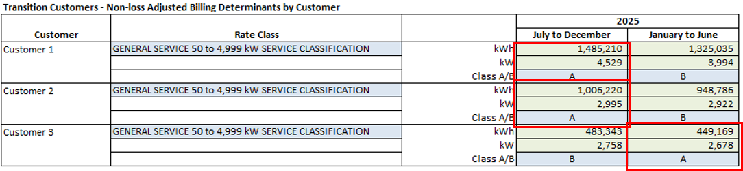

Ref. 2:
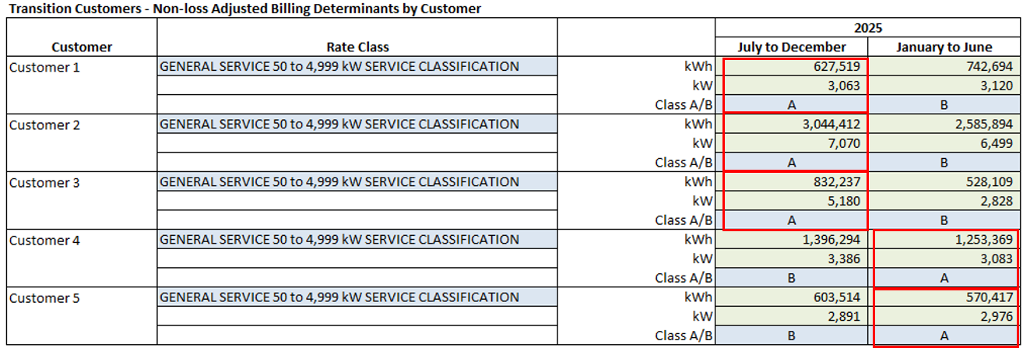

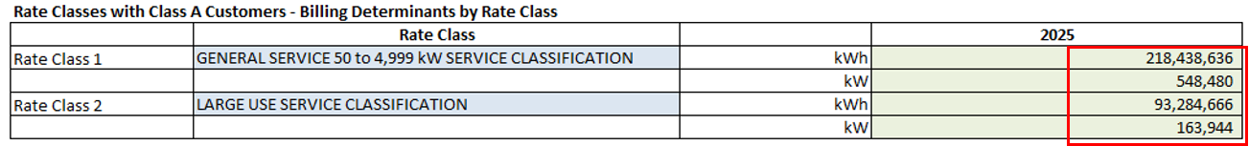

Question(s):
- The total for the combined Class A Consumption Data does not match the RRR data provided. Please provide the reason for the discrepancy and update as required.

Staff Question-
Ref. 1: ENOVA_APPL_2027 IRM_KWRZ_IRM Rate Generator Model_V2_20260810, Tab 8 STS Tax Change
Ref. 2: KWHI_DRF_RO_2020_Rev_Reqt_Work_Form_20191107, Tab 6 Taxes_PILs

Preamble:
In Ref. 1, the ‘OEB-Approved Regulatory Taxable Income’ and ‘Combined Effective Tax Rate’ are as below:

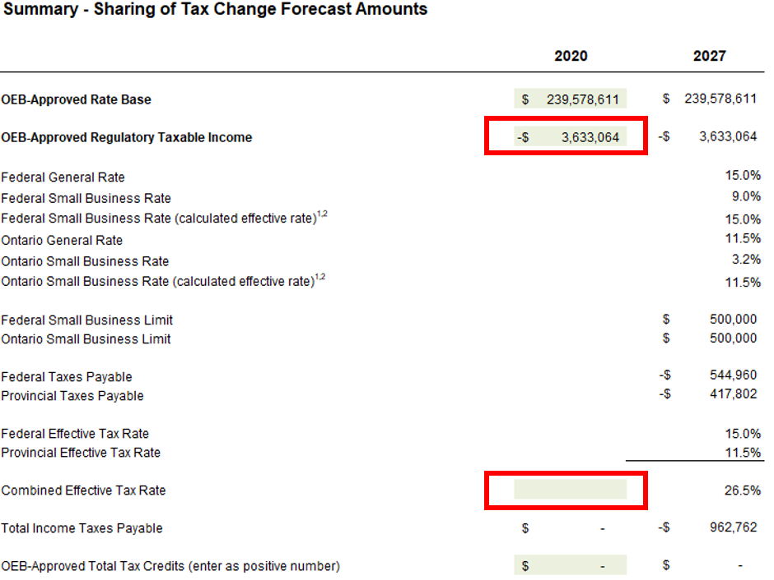

In Ref. 2, the values are as below:
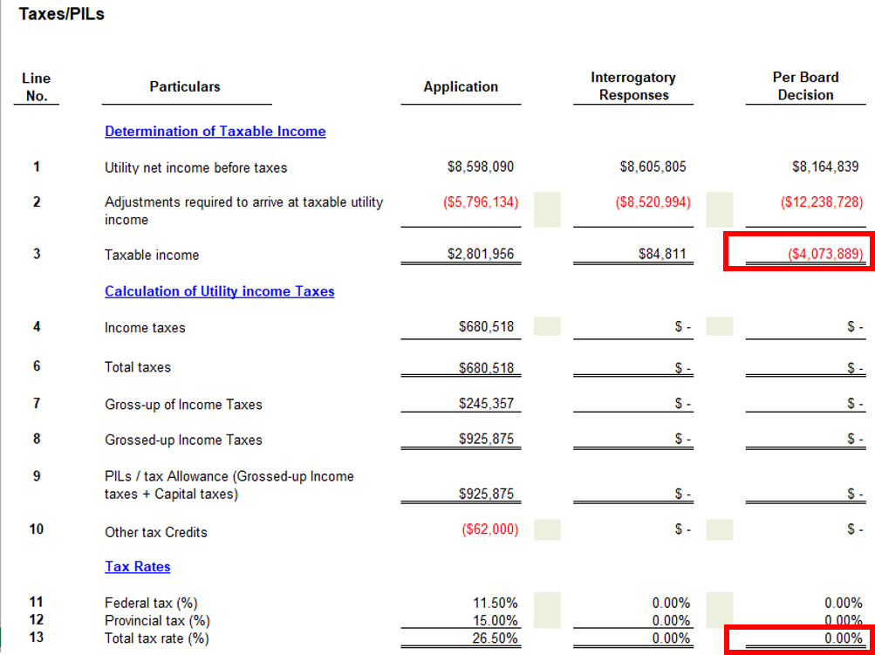

Question(s):
- Please provide the reason for the discrepancy between Ref. 1 and Ref. 2, and update as necessary.
Staff Question-
Ref. 1: ENOVA_APPL_2027 IRM_KWRZ_IRM Rate Generator Model_20260929
Ref. 2: ENOVA_APPL_2027 IRM_WNRZ_IRM Rate Generator Model_20260929

Question(s):
- In the instance the OEB releases any updated rates/charges (e.g., 2027 preliminary Uniform Transmission Rates) before Enova Power provides its responses to OEB staff’s questions, please update the Rate Generator Models, as applicable. If any updates are made, please identify the rate and/or charge that have been updated.
Staff Question-
Ref. 1: ENOVA_APPL_2027 IRM_KWRZ_IRM Rate Generator Model_20260929, Tab 19 Additional Rates
Ref. 2: ENOVA_APPL_2027 IRM_WNRZ_IRM Rate Generator Model_20260929, Tab 19 Additional Rates

Preamble:
As per the Case Management Letter filed on September 8, 2026, the OEB accepted Enova Power’s request to bifurcate the proceeding. Phase 1 is to address the IRM rate adjustment and related matters, and Phase 2 is to address the ICM funding request.
OEB staff has updated both Ref. 1 and Ref. 2, to no longer have the ICM rate riders.
Question(s):
- Please confirm the accuracy of the updates. Also, please confirm that these updates are accurately showing up in Tab 20 and Tab 21.
Staff Question-
Ref. 1: ENOVA_APPL_2027 IRM_KWRZ_IRM Rate Generator Model_20260929, Tab 21 Bill Impacts

Preamble:
OEB staff has updated Cell I432 to reflect the value of the DVA rate rider in Ref. 1 for the Embedded Distributor Service Classification.

Question(s):
- Please confirm the accuracy of the update and that it is flowing through correctly.

Staff Question-
Ref. 1: ENOVA_APPL_2027 IRM_WNRZ_IRM Rate Generator Model_20260929, Tab 21 Bill Impacts

Preamble:
In Ref. 1, OEB staff has updated Cell I246. Previously, the Cell was including the RTSR values even for EV Charging.

Question(s):
- Please confirm the accuracy of the update and that it is flowing through correctly.

Staff Question-
Ref. 1: OEB Accounting Guidance Related to Commodity Pass-Through Accounts 1588 & 1589 (Accounting Guidance), April 28, 2025
Ref. 2: Updated Illustrative Commodity Model, April 28, 2025

The OEB issued final updates to the Accounting Guidance and the updated Ilustrative Commodity Model related to the implementation of the Independent Electricity System Operator (IESO)’s Market Renewal Program (MRP), effective May 1, 2025. Page 11 of Reference 1 states that:

In Tab “Variances in ac 1588” of the updated Illustrative Commodity Model, two new tables are added to quantify the energy variances that are included in Account 1588 for records-keeping purposes. While the quantification tables are not required to be filed with the OEB at this time, these tables assist the distributors in explaining the 1% threshold test in Account 1588.

Reference 2 introduced two new reconciliation tables under the “Variances in ac 1588” tab to quantify energy cost variances arising from the implementation of MRP. In Page 11 of Reference 1, the OEB stated that these tables are intended for record-keeping purposes and are not required to be filed with the OEB. However, these two reconciliation tables may assist the distributors in explaining the 1% threshold test in Account 1588 where applicable.

Question(s):
- Has Enova Power utilized Table 42 and/or 43 of Ref. 2 to track or quantify the MRP-related energy variances recorded in Account 1588?
- If so, please explain whether the variances recorded in Table 42 and Table 43 were material in 2025, respectively. Please provide the corresponding quantum of the variances if the variance(s) are material.
- If not, please explain why not.

